**Practical No 1.1 : write a menu driven program to reverse number, sum of digits an palindrome.**

**Source code:**

import java.io.*;

import java.util.*;

class Demo1

{

public static void main(String args[])

{

Scanner sc=new Scanner(System.in);

int n,rev=0,rem;

System.out.println("1.Reverse Number");

System.out.println("2.Sum of Digits");

System.out.println("3.Palindrome");

System.out.println("Enter your choice: ");

n=sc.nextInt();

switch(n)

{

case 1:

System.out.println("\nEnter Integer: ");

int num=sc.nextInt();

while(num!=0)

{

rem=num%10;

rev=rev*10+rem;

num=num/10;

}

System.out.println("Reverse Number: "+rev);

break;

case 2:

System.out.println("\nEnter Integer: ");

int num1=sc.nextInt();

while(num1!=0)

{

rem=num1%10;

rev=rev+rem;

num1=num1/10;

}

System.out.println("sum of digits: "+rev);

break;

case 3:

System.out.println("\nEnter Integer: ");

int num3=sc.nextInt();

int temp=num3;

while(num3!=0)

{

rem=num3%10;

rev=rev*10+rem;

num3=num3/10;

}

if(temp==rev)

{

System.out.println("It is palindrome");

}

else

{

System.out.println("It is not palindrome");

}

break;

}

}

}

**Output:**

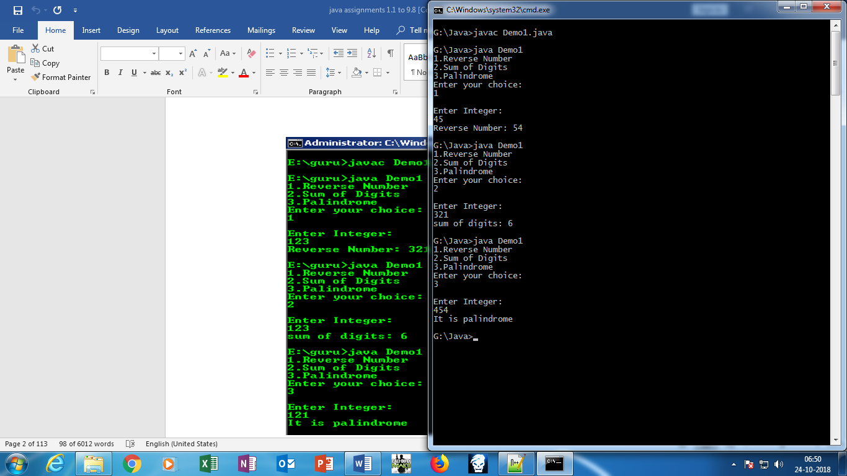

**Practical No 1.2 : write a menu driven program to find factorial , Fibonacci, even number and multiplication table of a given number.**

**Source Code:**

import java.io.*;

import java.util.*;

class Demo

{

public static void main(String args[])

{

Scanner sc=new Scanner(System.in);

int n,fact=1,a=0,b=1,c,num;

char choice;

do{

System.out.println("1.Factorial");

System.out.println("\n2.Fibonacci series");

System.out.println("\n3.Even & Odd");

System.out.println("\n4.Multiplication table");

System.out.println("\nEnter your choice");

n=sc.nextInt();

switch(n)

{

case 1:

System.out.println("Enter no.:");

num=sc.nextInt();

for(int i=1;i<=num;i++)

{

fact=fact*i;

}

System.out.println("The factorial no. is"+fact);

break;

case 2:

System.out.println("Enter a number");

int num1=sc.nextInt();

System.out.print(a+" ");

while(a<=num1)

{

c=a+b;

a=b;

b=c;

System.out.print(a+ "\t");

}

break;

case 3:

System.out.println("enter a no.");

int number=sc.nextInt();

if(number%2==0)

{

System.out.println("Number is even");

}

else

{

System.out.println("Number is odd");

}

break;

case 4:

int tableSize=10;

System.out.format(" ");

for(int i = 1; i<=tableSize;i++ )

{

System.out.format("%4d",i);

}

System.out.println();

System.out.println("----------------------------------------------");

for(int i = 1 ;i<=tableSize;i++)

{

System.out.format("%4d |",i);

for(int j=1;j<=tableSize;j++)

{

System.out.format("%4d",i*j);

}

System.out.println();

}

break;

}

System.out.println("\nDo you want to continue[Y/N]:");

choice=sc.next().charAt(0);

}while(choice=='y' || choice=='Y');

}

}

**Output:**

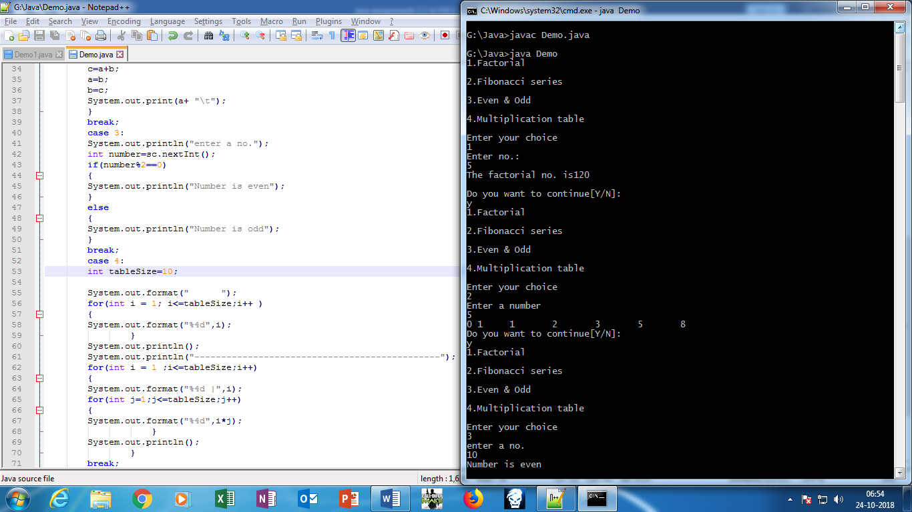

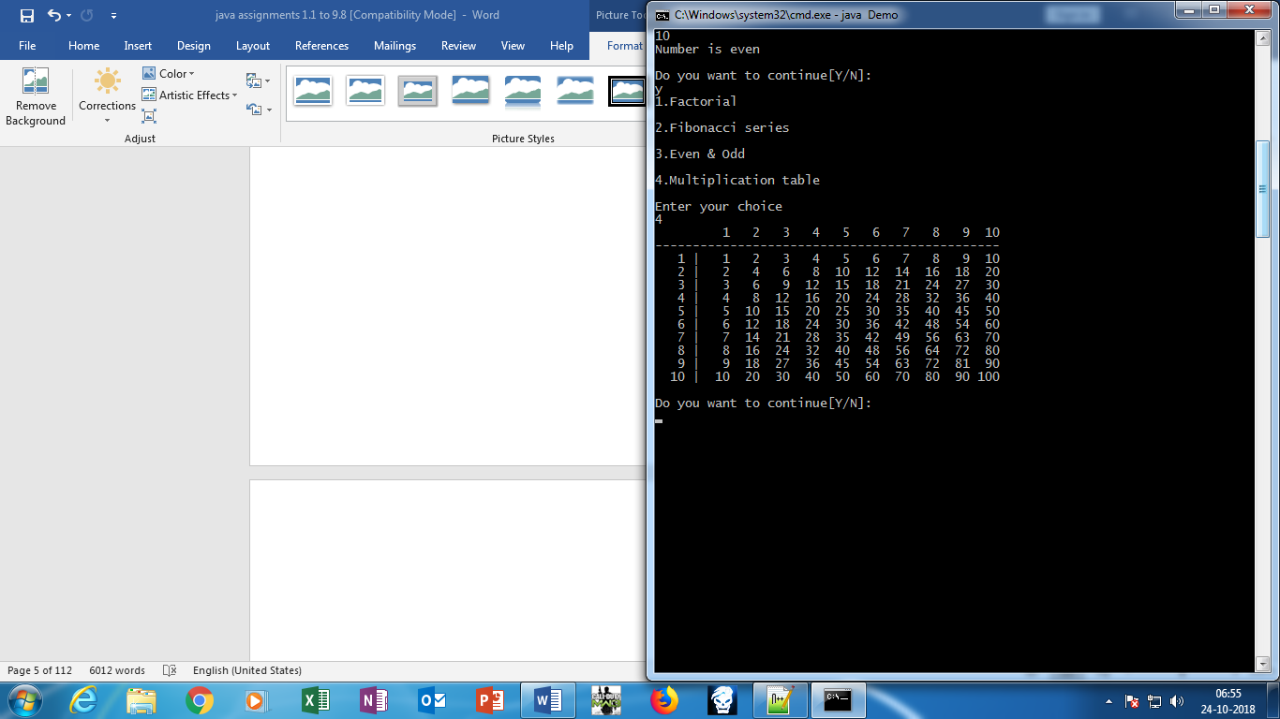

**Practical No 1.3 : write a menu driven program to Open Notepad,Find IP address,Find Date and Time,System Restart,System Shutdown.**

**Source Code:**

import java.io.*;

import java.util.*;

import java.net.*;

class Demo2

{

public static void main(String args[]) throws Exception

{

int n;

char ch;

Scanner sc=new Scanner(System.in);

do

{

System.out.println("******Menu Driven******");

System.out.println("\n\n1.Open Notepad");

System.out.println("\n2.Find IP address");

System.out.println("\n3.Find Date and Time");

System.out.println("\n4.System Restart");

System.out.println("\n5.System Shutdown");

System.out.println("\nEnter Your choice: ");

n=sc.nextInt();

Runtime r=Runtime.getRuntime();

switch(n)

{

case 1:

System.out.println("Open Notepad");

r.exec("notepad");

break;

case 2:

System.out.println("IP Address");

System.out.println(InetAddress.getLocalHost());

break;

case 3:

int day, month, year;

int second, minute, hour;

GregorianCalendar date = new GregorianCalendar();

day = date.get(Calendar.DAY_OF_MONTH);

month = date.get(Calendar.MONTH);

year = date.get(Calendar.YEAR);

second = date.get(Calendar.SECOND);

minute = date.get(Calendar.MINUTE);

hour = date.get(Calendar.HOUR);

System.out.println("Current date is "+day+"/"+(month+1)+"/"+year);

System.out.println("Current time is "+hour+" : "+minute+" : "+second);

break;

case 4:

System.out.println("PC Restart");

r.exec("shutdown -r");

break;

case 5:

System.out.println("PC Shutdown");

r.exec("shutdown -s -t 30");

break;

}

System.out.println("\nDo you want to continue[Y or N]: ");

ch=sc.next().charAt(0);

}while(ch=='Y' || ch=='y');

}

}

**Output:**

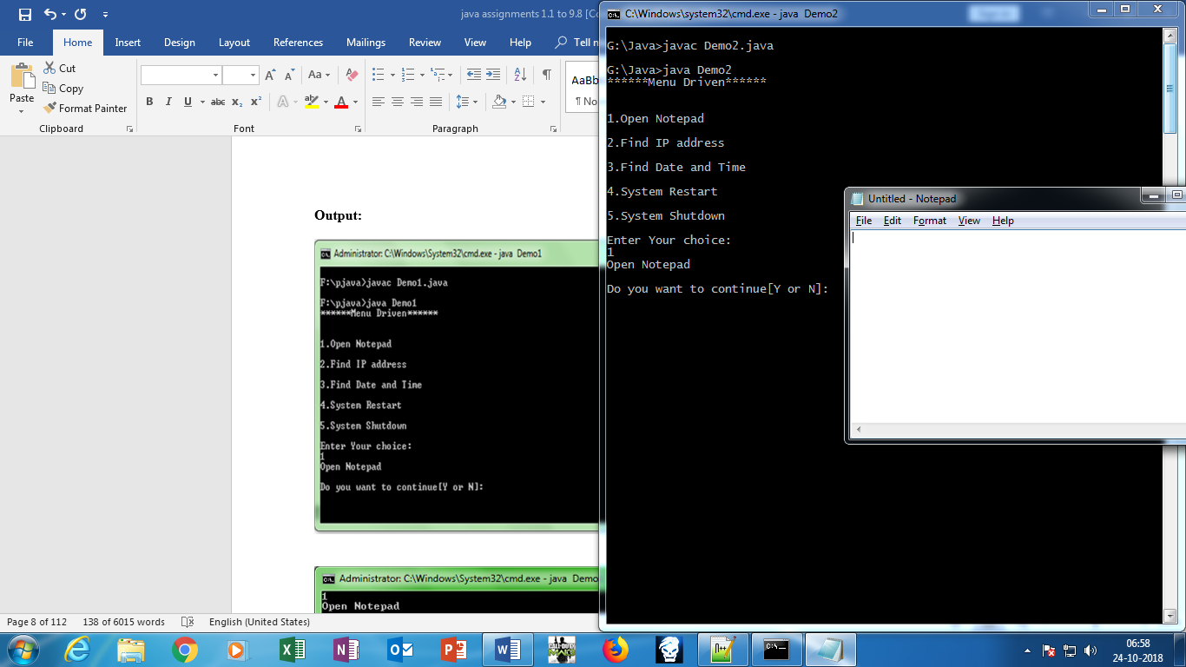

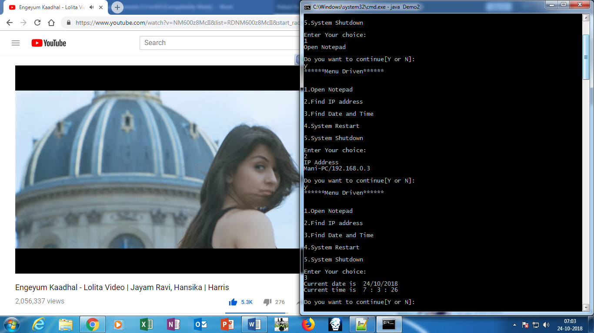

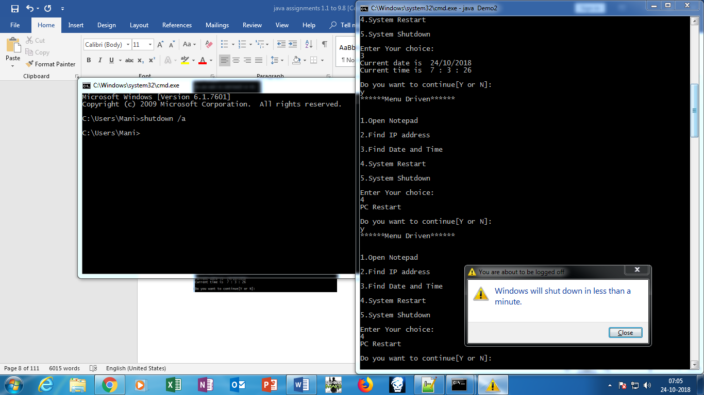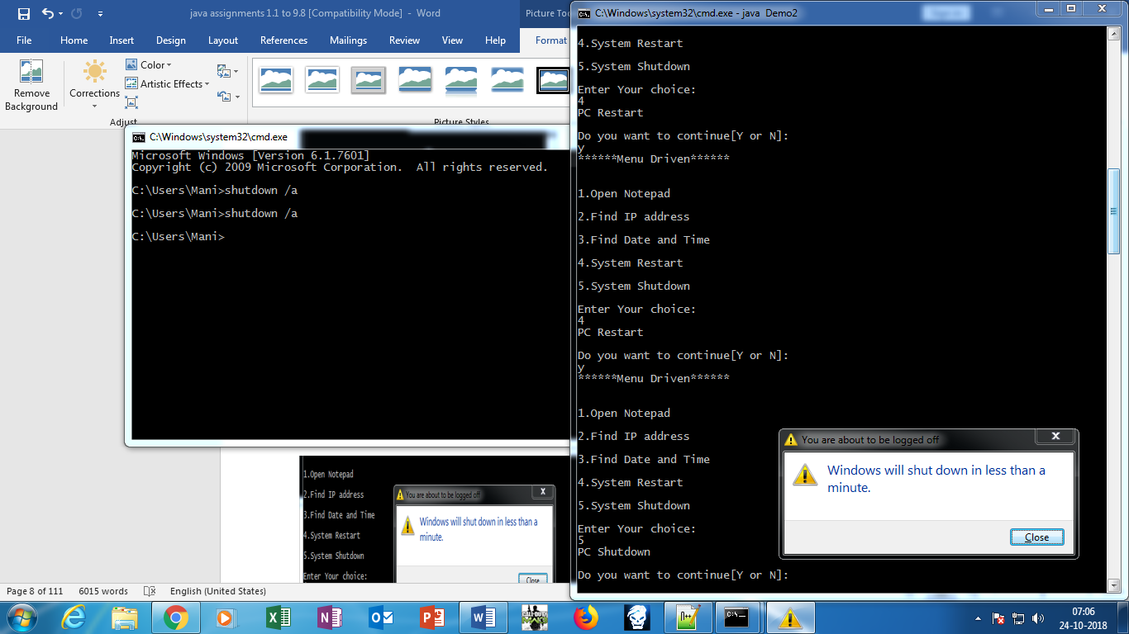

**Practical No 2.1: write a program to demonstrate the use of constructors.**

Source Code:

import java.io.*;

import java.util.*;

class pract21

{

double a,r,h;

pract21()

{

a=1;

r=2;

h=3;

System.out.println("Using default constructor");

System.out.println("\nVolume of cube= "+(a*a*a));

System.out.println("\nVolume of cylinder= "+(3.14*r*r*h));

System.out.println("\nVolume of cone= "+(3.14*r*r*h/3));

}

pract21(double a1,double r1,double h1)

{

a=a1;

r=r1;

h=h1;

System.out.println("\nUsing parametrized constructor");

System.out.println("\nVolume of cube= "+(a*a*a));

System.out.println("\nVolume of cylinder= "+(3.14*r*r*h));

System.out.println("\nVolume of cone= "+(3.14*r*r*h/3));

}

pract21(pract21 obj)

{

a=obj.a;

r=obj.r;

h=obj.h;

System.out.println("\nUsing copy constructor");

System.out.println("\nVolume of cube= "+(a*a*a));

System.out.println("\nVolume of cylinder= "+(3.14*r*r*h));

System.out.println("\nVolume of cone= "+(3.14*r*r*h/3));

}

public static void main(String args[])

{

pract21 ob1=new pract21();

pract21 ob2=new pract21(2.12,3.11,5.04);

pract21 ob3=new pract21(ob2);

}

}

**Output:**

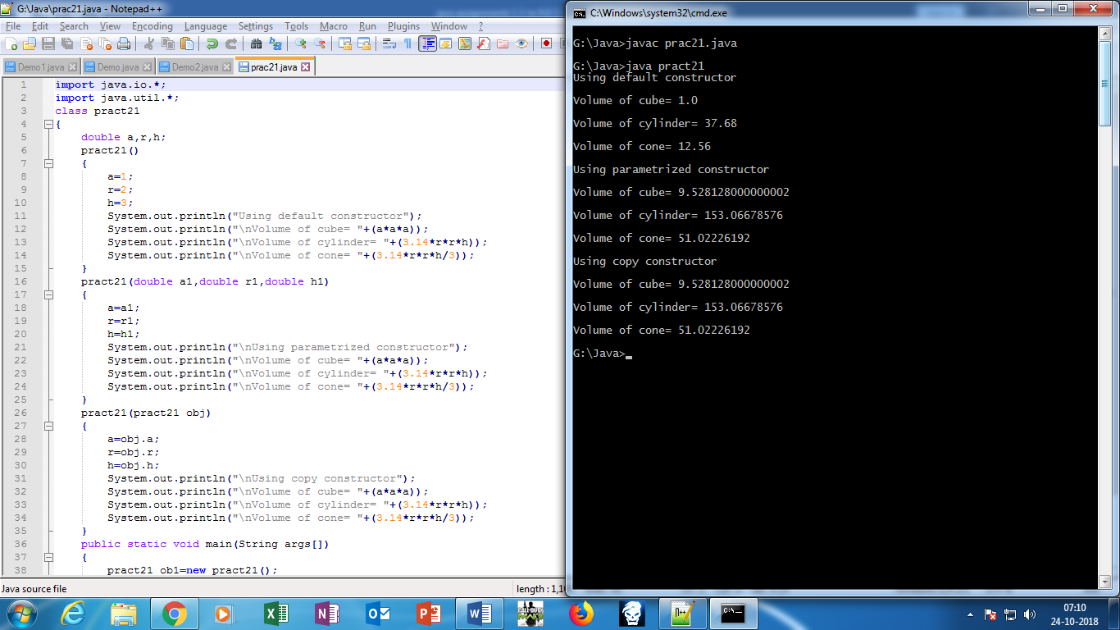

**Practical No 2.2 : write a program to demonstrate the use of finalize method and garbage collector.**

**Source Code:**

import java.io.*;

import java.util.*;

class ATM

{

double acc_no,balance=5000,withdraw,amt;

String acc_type;

int pin;

ATM()

{

Scanner sc=new Scanner(System.in);

System.out.println("\t\t*****Welcome To SBI Bank*****");

System.out.println("\nInsert Your Card------");

System.out.println("\nEnter Your PIN: ");

pin=sc.nextInt();

System.out.println("\nEnter Account Type: ");

acc_type=sc.nextLine();

System.out.println("\nEnter Withdraw Ammount: ");

withdraw=sc.nextDouble();

if(balance>withdraw)

{

System.out.println("\nBlanace Amount: "+(balance-withdraw));

}

else

{

System.out.println("\nInsufficent Balance");

}

}

public void finalize()

{

System.out.println("\nThank you..............Visit Again To our ATM");

}

public static void main(String args[])

{

ATM obj=new ATM();

obj=null;

System.gc();

}

}

**Output:**

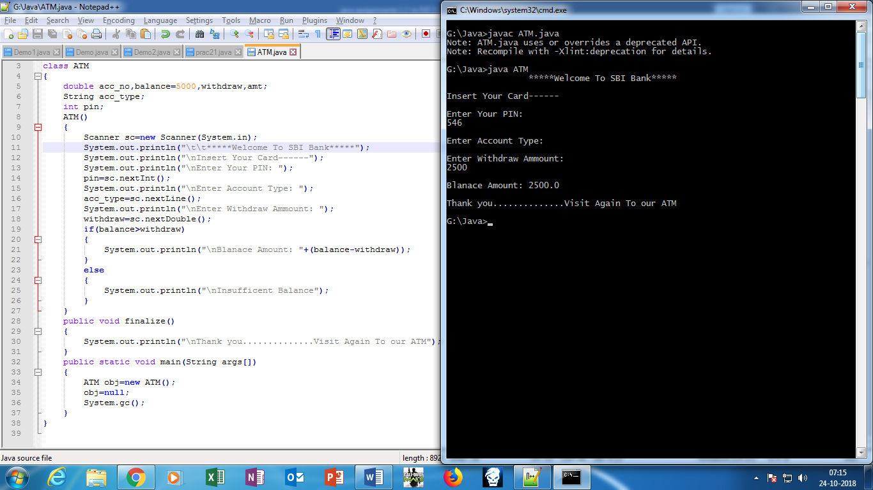

**Practical No 2.3: write a program to show the use of static keyword.**

**Source Code:**

import java.io.*;

import java.util.*;

class product

{

String product_name;

int prod_quantity,price,total;

static int count=0;

product()

{

Scanner sc=new Scanner(System.in);

System.out.println("\n\nWelcome to Rubix Cube Shopping");

System.out.print("\nEnter product name: ");

product_name=sc.nextLine();

System.out.print("\nEnter Product price: ");

price=sc.nextInt();

System.out.print("\nEnter product Quantity: ");

prod_quantity=sc.nextInt();

System.out.println("Total Bill: "+(price*prod_quantity));

}

static void disp()

{

++count;

System.out.println("Customer No.: "+count);

}

static

{

System.out.println("\t\t****Product Details****");

}

public static void main(String args[])

{

product ob1=new product();

product.disp();

product ob2=new product();

product.disp();

product ob3=new product();

product.disp();

}

}

**Output:**

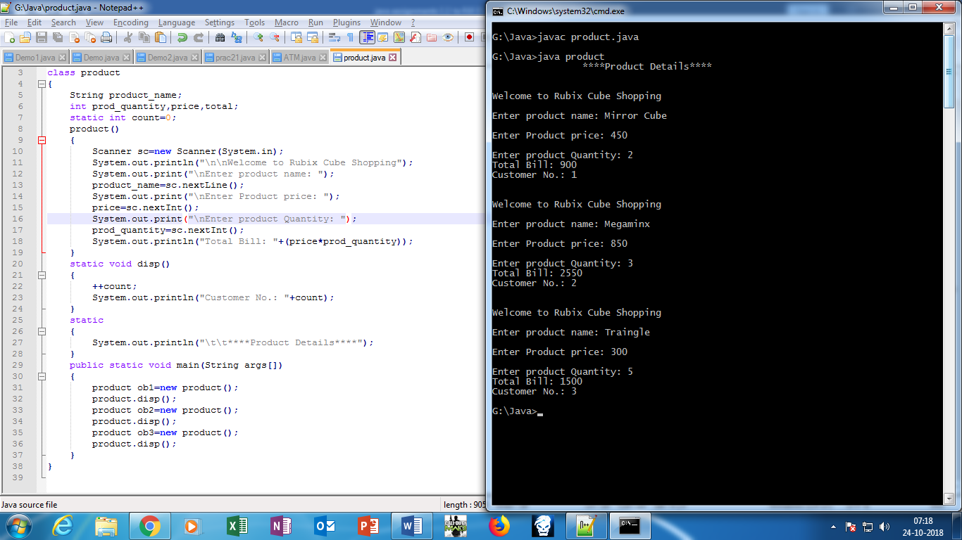

**Practical 2.4 : write a program o demonstrate multilevel inheritance.**

**Source Code:**

import java.io.*;

import java.util.*;

class college

{

String name,add;

void get()

{

Scanner ob=new Scanner(System.in);

System.out.println("Enter College Name: ");

name=ob.next();

System.out.println("\nEnter College Address: ");

add=ob.next();

}

void display()

{

System.out.println("\nCollege Name: "+name);

System.out.println("\nCollege Address: "+add);

}

}

class student extends college

{

String name1,course;

int roll;

void get1()

{

get();

Scanner ob1=new Scanner(System.in);

System.out.println("\nEnter student Name: ");

name1=ob1.next();

System.out.println("\nEnter student Course Name: ");

course=ob1.next();

System.out.println("\nEnter student Roll Number: ");

roll=ob1.nextInt();

}

void display1()

{

display();

System.out.println("\nStudent Roll Number: "+roll);

System.out.println("\nStudent Name: "+name1);

System.out.println("\nStudent Course Name: "+course);

}

}

class fees extends student

{

double total,paid,balance;

void get2()

{

get1();

Scanner ob2=new Scanner(System.in);

System.out.println("\nEnter total fees: ");

total=ob2.nextDouble();

System.out.println("\nEnter paid balance: ");

paid=ob2.nextDouble();

}

void display2()

{

display1();

System.out.println("\nTotal Balance: "+total);

System.out.println("\nPaid Balance: "+paid);

balance=total-paid;

System.out.println("\nBalance: "+balance);

}

}

class abc

{

public static void main(String args[])

{

fees obj=new fees();

obj.get2();

obj.display2();

}

}

**Output:**

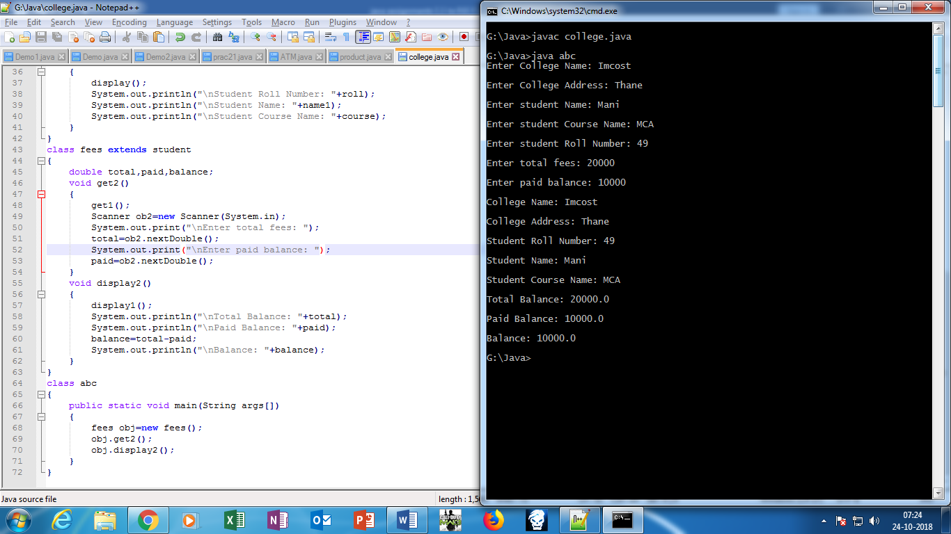

**Practical No.2.5 : Inheritance**

**Source Code:**

import java.io.*;

import java.util.*;

class book

{

String name,aname;

int price;

void get()

{

Scanner ob=new Scanner(System.in);

System.out.print("Enter Book Name: ");

name=ob.next();

System.out.print("\nEnter Author Name: ");

aname=ob.next();

System.out.print("\nEnter Book Price: ");

price=ob.nextInt();

}

void display()

{

System.out.println("\nBook Name: "+name);

System.out.println("\nAuthor Name: "+aname);

System.out.println("\nBook Price: "+price);

}

}

class C extends book

{

String name1;

int ver;

void get1()

{

get();

Scanner ob1=new Scanner(System.in);

System.out.print("\nEnter Software Name: ");

name1=ob1.next();

System.out.print("\nEnter Version Number: ");

ver=ob1.nextInt();

}

void display1()

{

display();

System.out.println("\nSoftware Name: "+name1);

System.out.println("\nSoftware Version: "+ver);

}

}

class cpp extends book

{

String name2;

int ver1;

void get2()

{

get();

Scanner ob2=new Scanner(System.in);

System.out.print("\nEnter Software Name: ");

name2=ob2.next();

System.out.print("\nEnter Version Number: ");

ver1=ob2.nextInt();

}

void display2()

{

display();

System.out.println("\nSoftware Name: "+name2);

System.out.println("\nSoftware Version: "+ver1);

}

}

class java extends book

{

String name3;

int ver2;

void get3()

{

get();

Scanner ob3=new Scanner(System.in);

System.out.println("\nEnter Software Name: ");

name3=ob3.next();

System.out.println("\nEnter Version Number: ");

ver2=ob3.nextInt();

}

void display3()

{

display();

System.out.println("\nSoftware Name: "+name3);

System.out.println("\nSoftware Version: "+ver2);

}

}

class MainDemo

{

public static void main(String args[])

{

C obj=new C();

obj.get1();

obj.display1();

cpp obj1=new cpp();

obj1.get2();

obj1.display2();

java obj2=new java();

obj2.get3();

obj2.display3();

}

}

**Output:**

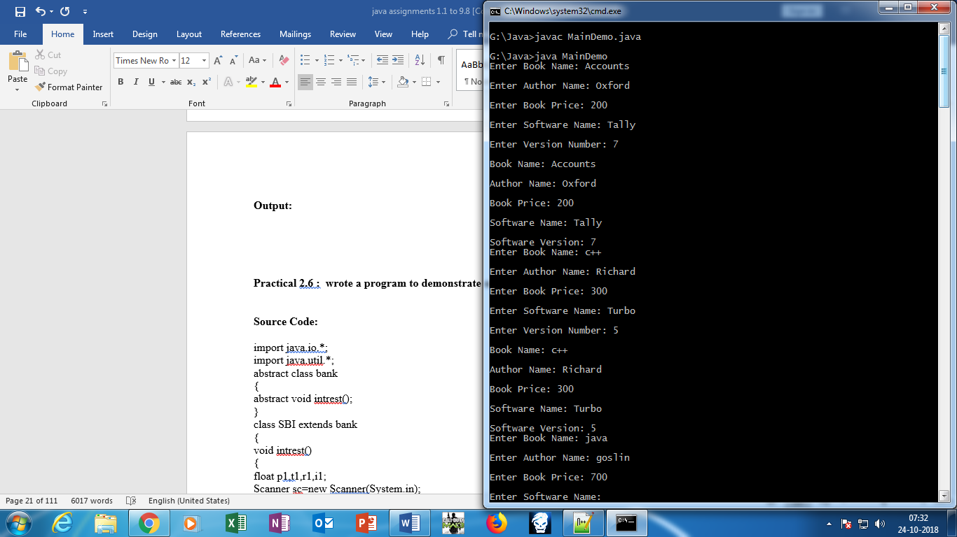

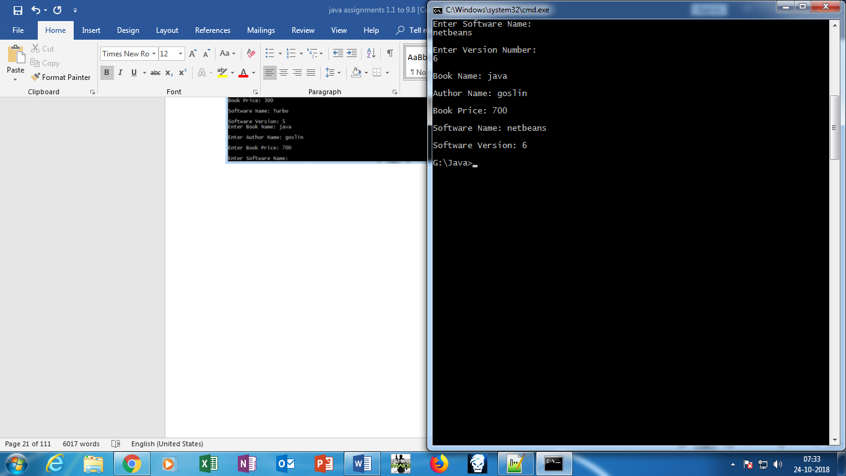

**Practical 2.6 : wrote a program to demonstrate use of abstract class and methods.**

**Source Code:**

import java.io.*;

import java.util.*;

abstract class bank

{

abstract void intrest();

}

class SBI extends bank

{

void intrest()

{

float p1,t1,r1,i1;

Scanner sc=new Scanner(System.in);

System.out.print("Enter Amount: ");

p1=sc.nextFloat();

System.out.print("\nEnter Time Period: ");

t1=sc.nextFloat();

System.out.print("\nEnter Rate of intrest: ");

r1=sc.nextFloat();

i1=(p1*r1*t1)/100;

System.out.println("Rate Of Intrest of SBI Bank: "+i1);

}

}

class COSMOS extends bank

{

void intrest()

{

float p2,t2,r2,i2;

Scanner sc2=new Scanner(System.in);

System.out.print("\nEnter Amount: ");

p2=sc2.nextFloat();

System.out.print("\nEnter Time Period: ");

t2=sc2.nextFloat();

System.out.print("\nEnter Rate of intrest: ");

r2=sc2.nextFloat();

i2=(p2*r2*t2)/100;

System.out.println("Rate Of Intrest of COSMOS Bank: "+i2);

}

}

class ICICI extends bank

{

void intrest()

{

float p3,t3,r3,i3;

Scanner sc3=new Scanner(System.in);

System.out.print("Enter Amount: ");

p3=sc3.nextFloat();

System.out.print("\nEnter Time Period: ");

t3=sc3.nextFloat();

System.out.print("\nEnter Rate of intrest: ");

r3=sc3.nextFloat();

i3=(p3*r3*t3)/100;

System.out.println("Rate Of Intrest of ICICI Bank: "+i3);

}

}

class MainDemo1

{

public static void main(String args[])

{

int n;

Scanner c=new Scanner(System.in);

System.out.print("\nSelect Bank Number: ");

System.out.print("\n1.SBI");

System.out.print("\n2.COSMOS");

System.out.print("\n3.ICICI");

System.out.print("\nEnter the Bank Number: ");

n=c.nextInt();

switch(n)

{

case 1:

bank ob=new SBI();

ob.intrest();

break;

case 2:

bank ob1=new COSMOS();

ob1.intrest();

break;

case 3:

bank ob2=new ICICI();

ob2.intrest();

break;

}

}

}

**Output:**

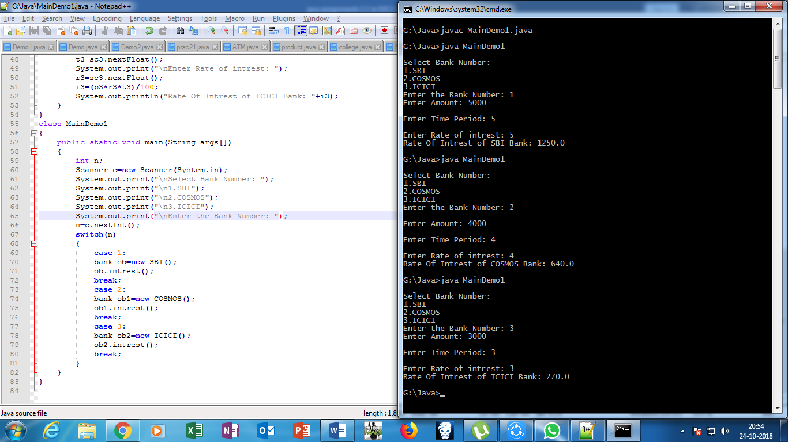

**Practical 2.7 : write a program to demonstrate use of interface.**

Source Code

import java.util.*;

interface FullTime

{

void salary();

}

interface PartTime

{

void salary1();

}

interface Visiting

{

void salary2();

}

class wages implements FullTime,PartTime,Visiting

{

public void salary()

{

int days;

float pay,sal;

Scanner sc=new Scanner(System.in);

System.out.print("Enter No.Of days = ");

days=sc.nextInt();

System.out.print("Enter per day payment = ");

pay=sc.nextFloat();

sal=days*pay;

System.out.println("Total Salary for FULLTIME employyes = "+sal);

}

public void salary1()

{

int days1;

float pay1,sal1;

Scanner sc=new Scanner(System.in);

System.out.print("Enter No.Of days = ");

days1=sc.nextInt();

System.out.print("Enter per day payment = ");

pay1=sc.nextFloat();

sal1=days1*pay1;

System.out.println("Total Salary for PARTTIME employyes = "+sal1);

}

public void salary2()

{

int hrs;

float pay3,sal3;

Scanner sc=new Scanner(System.in);

System.out.print("Enter No.Of hours = ");

hrs=sc.nextInt();

System.out.print("Enter per hour payment = ");

pay3=sc.nextFloat();

sal3=hrs*pay3;

System.out.println("Total Salary for FULLTIME employyes = "+sal3);

}

}

class Cal

{

public static void main(String args[])

{

wages w=new wages();

System.out.println("*********DETAILS OF FULLTIME********");

w.salary();

System.out.println("*********DETAILS OF PARTTIME********");

w.salary1();

System.out.println("*********DETAILS OF VISITING********");

w.salary2();

}

}

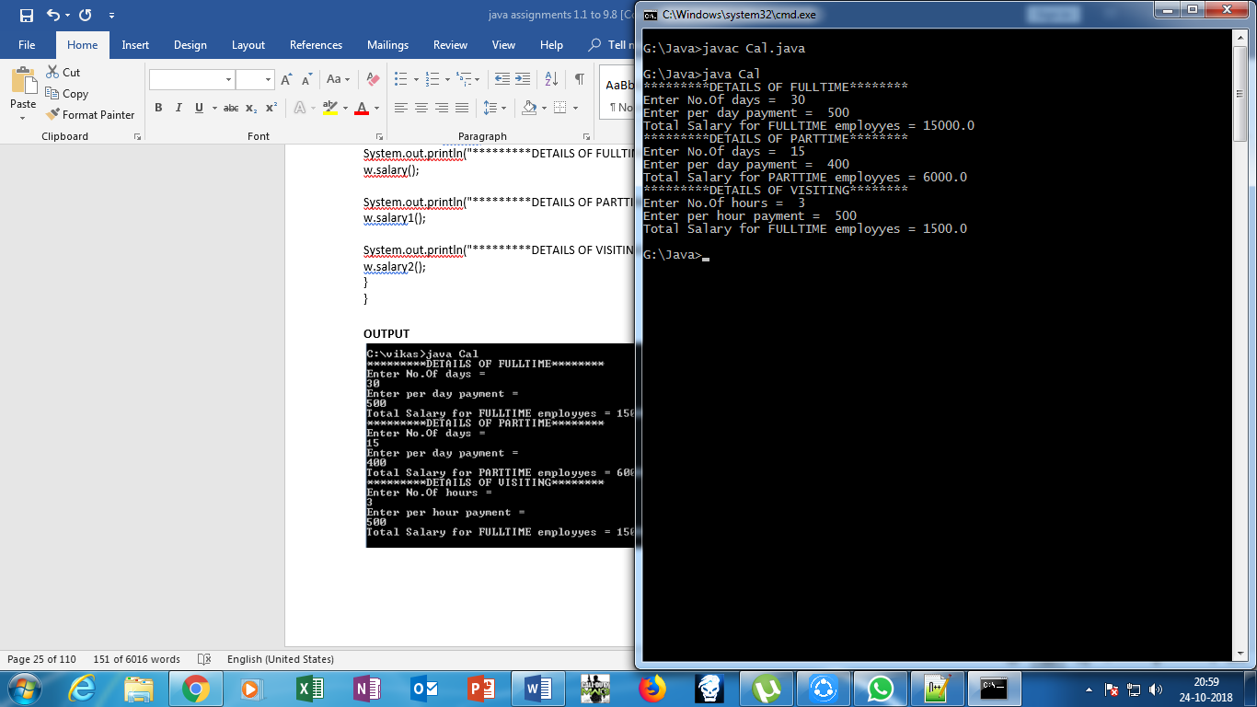**OUTPUT**

**Practical 2.8 . User Defined packages**

**INDIA.JAVA**

import andhrapradesh.*;

import maharashtra.pune.*;

import maharashtra.mumbai.*;

import delhi.*;

import gujrat.*;

import himachalpradesh.*;

import jharkhand.*;

import kerala.*;

import mp.*;

import up.*;

import orisa.*;

public class India

{

public static void main(String args[])

{

charminar ch=new charminar();

fort f=new fort();

beach b=new beach();

redfort r=new redfort();

sabarmati s=new sabarmati();

manali m= new manali();

canaryHill c=new canaryHill();

munnar mu=new munnar();

masjid ma=new masjid();

ganga g=new ganga();

puriBeach p=new puriBeach();

}

}

**Charminar.java**

package andhrapradesh;

public class charminar

{

public charminar()

{

System.out.println("charminar is aavilable in AP");

}

}

**Fort.java**

package maharashtra.pune;

public class fort

{

public fort()

{

System.out.println("shivneri fort is aavilable in pune");

}

}

**Beach.java**

package maharashtra.mumbai;

public class beach

{

public beach()

{

System.out.println("juhu beach is aavilable in mumbai");

}

}

**Redfort.java**

package delhi;

public class redfort

{

public redfort()

{

System.out.println("redfort is aavilable in delhi");

}

}

**Sabarmati.java**

package gujrat;

public class sabarmati

{

public sabarmati()

{

System.out.println("sabarmati ashram is aavilable in gujrat");

}

}

**Manali.java**

package himachalpradesh;

public class manali

{

public manali()

{

System.out.println("manali is aavilable in HP");

}

}

**canaryHilli.java**

package jharkhand;

public class canaryHill

{

public canaryHill()

{

System.out.println("canary Hill is aavilable in jharkhand");

}

}

**munnar.java**

package kerala;

public class munnar

{

public munnar()

{

System.out.println("munnar is aavilable in kerala");

}

}

**Ganga.java**

package up;

public class ganga

{

public ganga()

{

System.out.println("ganga is aavilable in UP");

}

}

**masjid.java**

package mp;

public class masjid

{

public masjid()

{

System.out.println("taj ul masjid is aavilable in MP");

}

}

**puriBeach.java**

package orisa;

public class puriBeach

{

public puriBeach()

{

System.out.println("puriBeach is aavilable in orisa");

}

}

**OUTPUT**

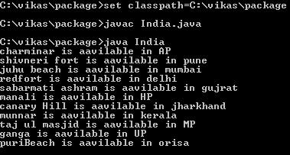

**Practical 2 .9 : write a program for all built in Math functions**

Source Code

import java.util.*;

import java.math.*;

import java.io.*;

class mathFuntions

{

void get()

{

Scanner sc=new Scanner(System.in);

double f,a,n,n1,n2,n3,n4,n5,n6;

System.out.print("Enter 1st value = ");

a=sc.nextDouble();

System.out.print("Enter 2nd value = ");

f=sc.nextDouble();

n=Math.abs(a);

System.out.println("absolute value = "+n);

n1=Math.pow(a,f);

System.out.println("Power = "+n1);

n2=Math.sqrt(a);

System.out.println("square of a = "+n2);

n3=Math.min(a,f);

System.out.println("Minimum value = "+n3);

n4=Math.max(a,f);

System.out.println("maximum value = "+n4);

n5=Math.ceil(f);

System.out.println("ceiling value = "+n5);

n6=Math.floor(a);

System.out.println("floor value = "+n6);

}

}

class main

{

public static void main(String args[])

{

mathFuntions m=new mathFuntions();

m.get();

}

}

**OUTPUT**

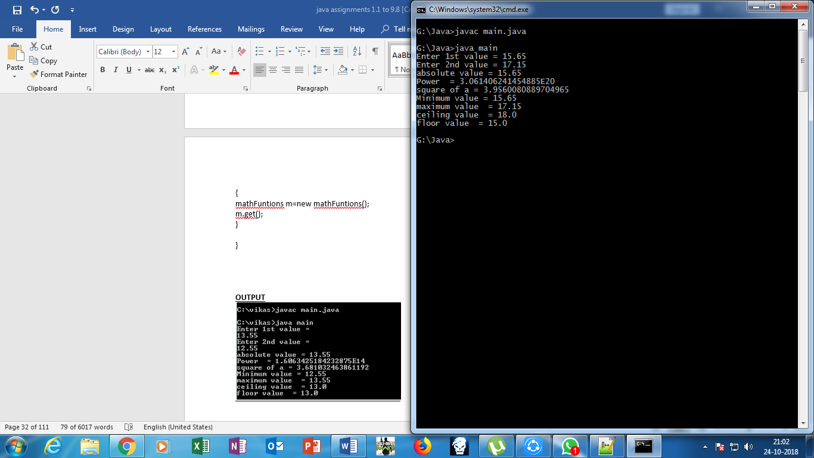

**PRACTICAL 3.1 : write a program to demonstrate Generic classes and generic methods.**

**Swapping.java**

Source Code

import java.util.*;

class swap<T>

{

T a,b,c; // generic datatypes

swap(T a,T b)

{

this.a=a;

this.b=b;

}

void display()

{

System.out.println("Values before swapping : a = "+a+" b = "+b);

c=a;

a=b;

b=c;

System.out.println("Values after swapping : a = "+a+" b = "+b);

}

}

class swapping

{

public static void main(String args[])

{

System.out.println(" ");

System.out.println("**************INTEGER VALUES*************");

swap<Integer> s=new swap<Integer>(10,20);

s.display();

System.out.println(" ");

System.out.println("**************FLOAT VALUES*************");

swap<Float> f=new swap<Float>(10.3f,20.3f);

f.display();

System.out.println(" ");

System.out.println("**************DOUBLE VALUES*************");

swap<Double> d=new swap<Double>(10.11111,20.22222);

d.display();

}

}

**OUTPUT:**

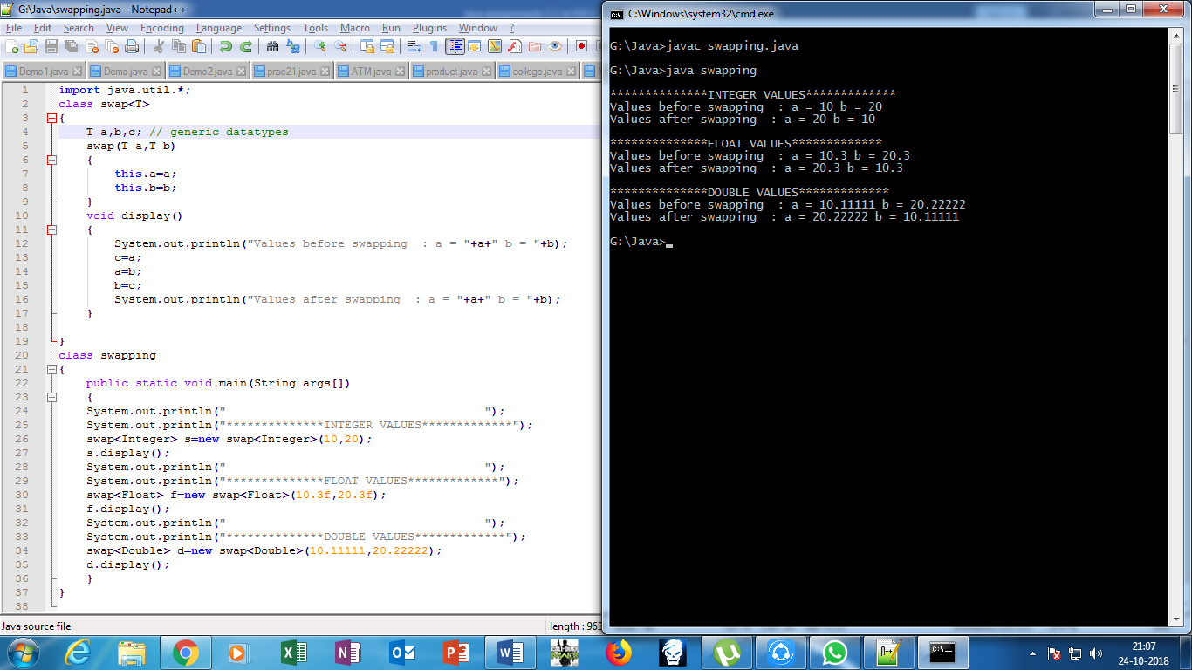

**PRACTICAL 3.2 : write a program of vectors.**

**Vector.java**

**Source Code**

import java.util.*;

class vector

{

public static void main(String args[])

{

Vector<Integer> a1=new Vector<Integer>();

a1.add(10);

a1.add(20);

a1.add(30);

System.out.println("Integer values of Vector " +a1);

Vector<String> s1=new Vector<String>();

s1.add("MCA");

s1.add("MMS");

s1.add("BMS");

System.out.println("String values of Vector " +s1);

}

}

**OUTPUT**

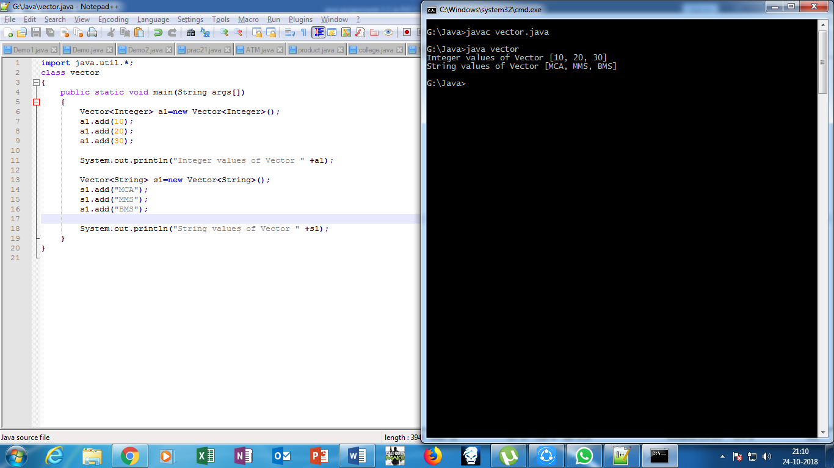

**PRACTICAL 3.3 : write a program of array list and linked list.**

**Lists.java**

**Source Code**

import java.util.*;

class lists

{

public static void main(String args[])

{

List<String> al=new ArrayList<String>();

al.add("vikas");

al.add("kharat");

al.add("ganesh ");

al.add("funde");

List<Integer> I=new ArrayList<Integer>();

I.add(88);

I.add(88);

I.add(11);

I.add(04);

I.add(16);

List<String> a2=new LinkedList<String>();

a2.add("imcost");

a2.add("thane");

a2.add("mumbai");

a2.add("40000");

List<Integer> I1=new LinkedList<Integer>();

I1.add(88);

I1.add(88);

I1.add(11);

I1.add(04);

I1.add(16);

System.out.println(" ");

System.out.println("arraylist String: "+al);

System.out.println(" ");

System.out.println("arraylist Integer: "+I);

System.out.println(" ");

System.out.println("linkedlist String: "+a2);

System.out.println(" ");

System.out.println("linkedlist Integer: "+I1);

}

}

**OUTPUT**

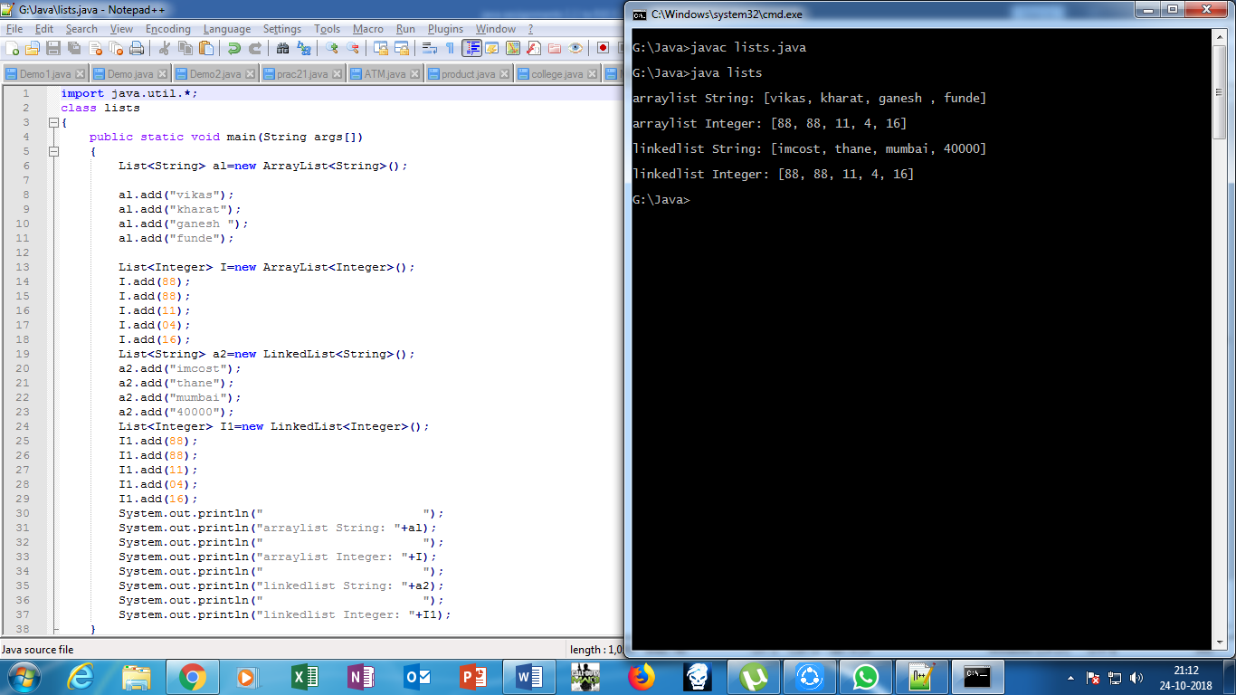

**PRACTICAL 4.1 : write a program of try catch and finally block.**

**Exc.java**

import java.util.*;

class Exc

{

public static void main(String args[])

{

try

{

int a=Integer.parseInt(args[0]);

int b=Integer.parseInt(args[1]);

int c=a/b;

System.out.println("Dividion is "+c);

}

catch(ArithmeticException e)

{

System.out.println("number not divisible by zero "+e);

}

catch(ArrayIndexOutOfBoundsException e)

{

System.out.println("For division two parameters are required "+e);

}

catch(NumberFormatException e)

{

System.out.println("Only Integer values have to accept "+e);

}

finally

{

System.out.println("finally block is always executed");

} }}

**OUTPUT**

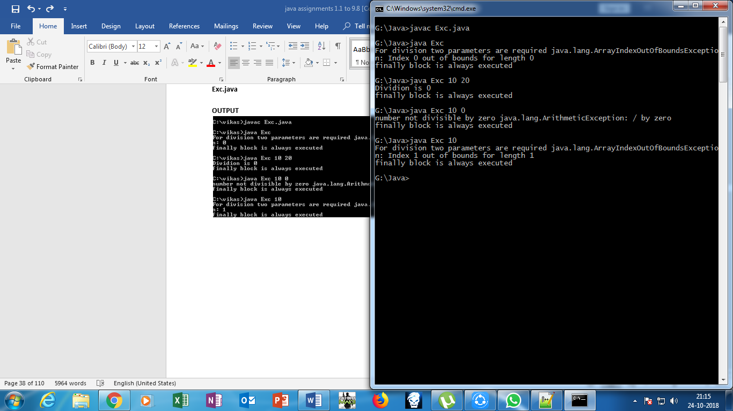

**Practical No. 4.2:- Write a program for throw and throws keyword.**

**Source code:**

import java.util.*;

class Exc1

{

public void get() throws ArithmeticException,ArrayIndexOutOfBoundsException,InputMismatchException

{

Scanner sc=new Scanner(System.in);

int a,b;

System.out.println("Enter the value of A: ");

a=sc.nextInt();

System.out.println("\nEnter the value of B: ");

b=sc.nextInt();

if(a==0 || b==0)

{

throw new ArithmeticException("Error1: Provide the value which Greater Than zero(0)!!");

}

else if(a<0 || b<0)

{

throw new ArrayIndexOutOfBoundsException("Error2: Provide the Positive value!!");

}

else if(a=='A' && a=='Z' && b=='A' && b=='Z' || a=='a' && a=='z' && b=='a' && b=='z')

{

throw new InputMismatchException("Error3: Provide the numeric value!!");

}

else

{

System.out.println("Valid Input!!");

}

}

public static void main(String args[])

{

Exc1 ob=new Exc1();

try

{

ob.get();

}

catch(ArithmeticException e)

{

System.out.println("Please Enter Value greater than zero: "+e);

}

catch(ArrayIndexOutOfBoundsException e)

{

System.out.println("Please Enter only positive: "+e);

}

catch(InputMismatchException e)

{

System.out.println("Please Enter only Integer value: "+e);

}

}

}

**Output:**

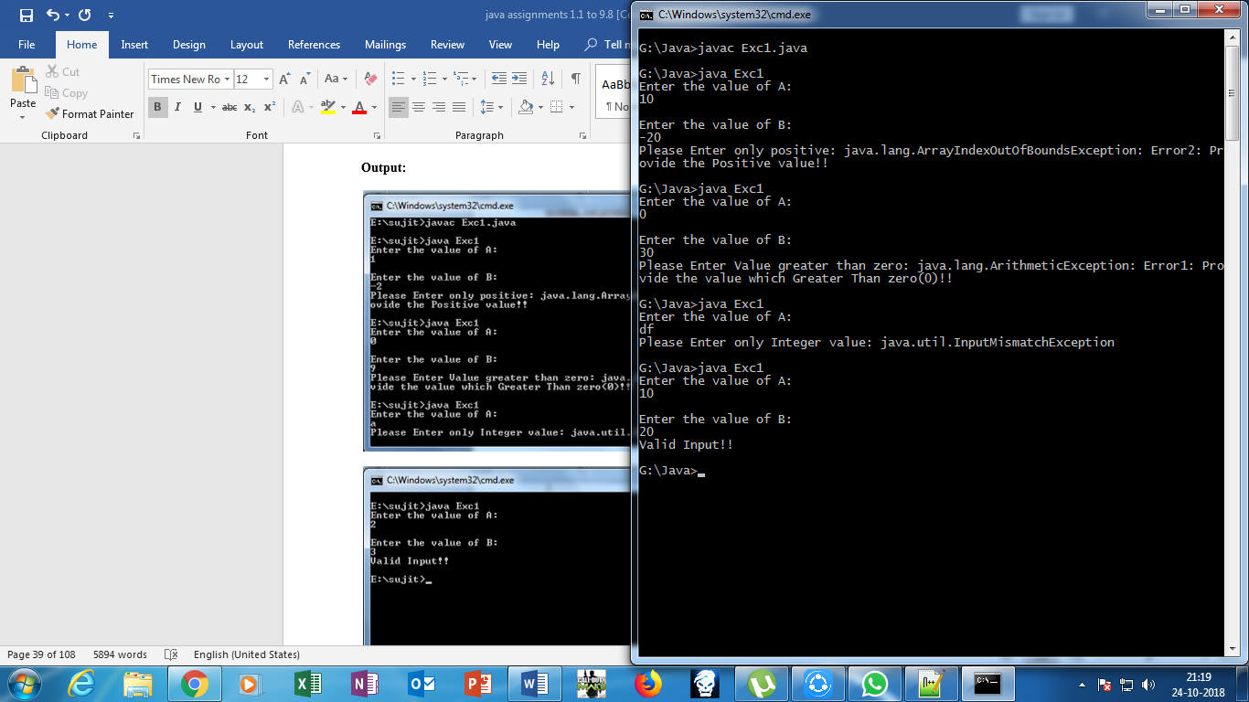

**Practical No.4.3: - Write a User Define Exception.**

**Source Code:**

import java.util.*;

class userpram extends Exception

{

public String toString()

{

return "Invalid parameters..............";

}

}

class userday extends Exception

{

public String toString()

{

return "Invalid Days..............";

}

}

class usermonth extends Exception

{

public String toString()

{

return "Invalid Month..............";

}

}

class userdefined

{

public static void main(String args[])

{

int d,m,y;

try

{

if(args.length<3)

{

throw new userpram();

}

else

{

d=Integer.parseInt(args[0]);

m=Integer.parseInt(args[1]);

y=Integer.parseInt(args[2]);

if(d<1 || d>31)

{

throw new userday();

}

else if(m<1 || m>12)

{

throw new usermonth();

}

else

{

System.out.println("Valid Date!!!!");

}

}

}

catch(Exception e)

{

System.out.println("Provide Correct Date: "+e);

}

}

}

**Output:**

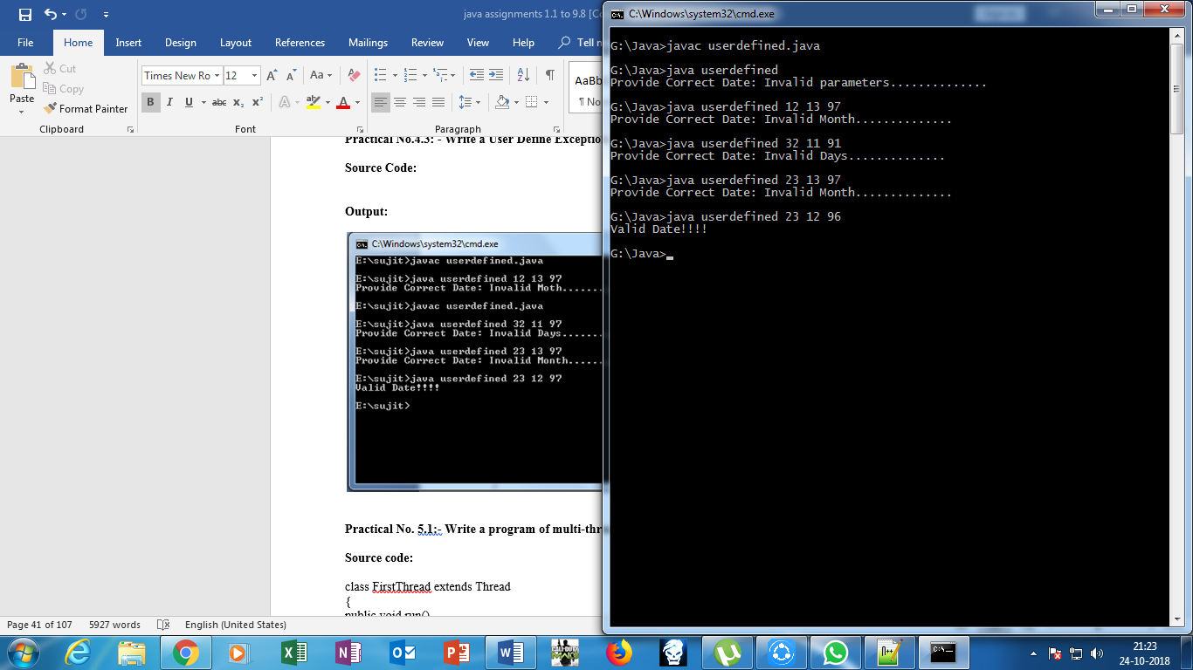

**Practical No. 5.1:- Write a program of multi-threading using extends keyword.**

**Source code:**

class FirstThread extends Thread

{

public void run()

{

int i;

for(i=0;i<5;i++)

{

System.out.println("First Thread: "+i);

}

System.out.println("\nFirst Thread");

}

}

class SecondThread extends Thread

{

public void run()

{

int i;

for(i=0;i<5;i++)

{

System.out.println("\nSecond Thread: "+i);

}

System.out.println("\nSecond Thread");

}

}

class Mainthread

{

public static void main(String args[])

{

FirstThread ft=new FirstThread();

SecondThread st=new SecondThread();

ft.start();

st.start();

}

}

**Output:**

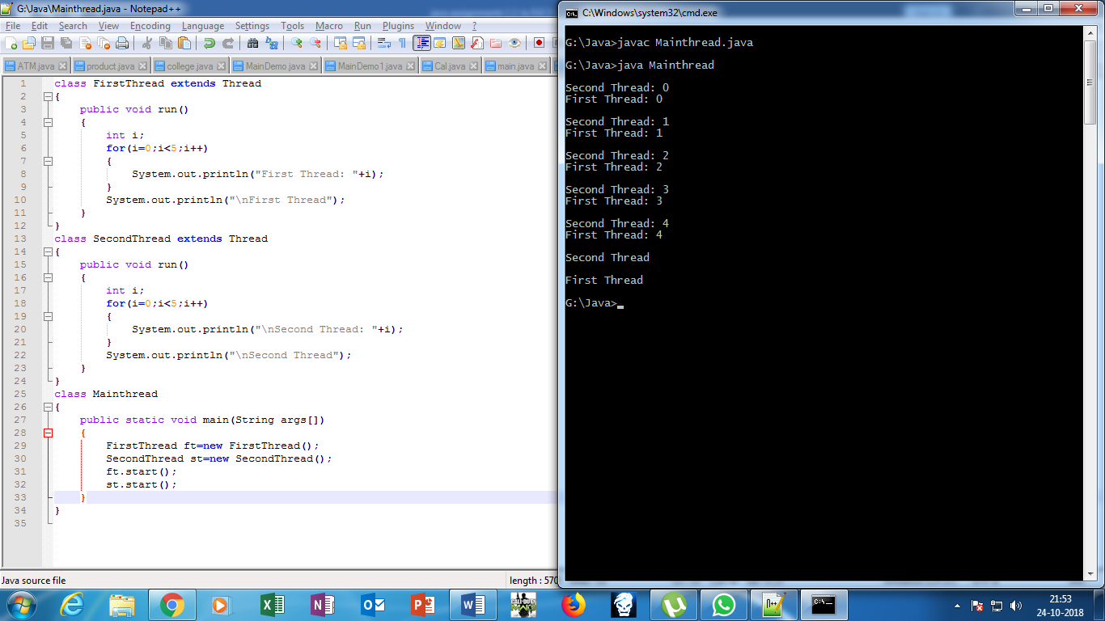

**Practical No. 5.2:- Write a program of multi-threading using implements interface.**

**Source code:**

class FirstThread implements Runnable

{

public void run()

{

int i;

for(i=0;i<5;i++)

{

System.out.println("First Thread: "+i);

}

System.out.println("\nFirst Thread");

}

}

class SecondThread implements Runnable

{

public void run()

{

int i;

for(i=0;i<5;i++)

{

System.out.println("\nSecond Thread: "+i);

}

System.out.println("\nSecond Thread");

}

}

class Mainthread1

{

public static void main(String args[])

{

FirstThread ft=new FirstThread();

SecondThread st=new SecondThread();

Thread f=new Thread(ft);

Thread s=new Thread(st);

f.start();

s.start();

}

}

**Output:**

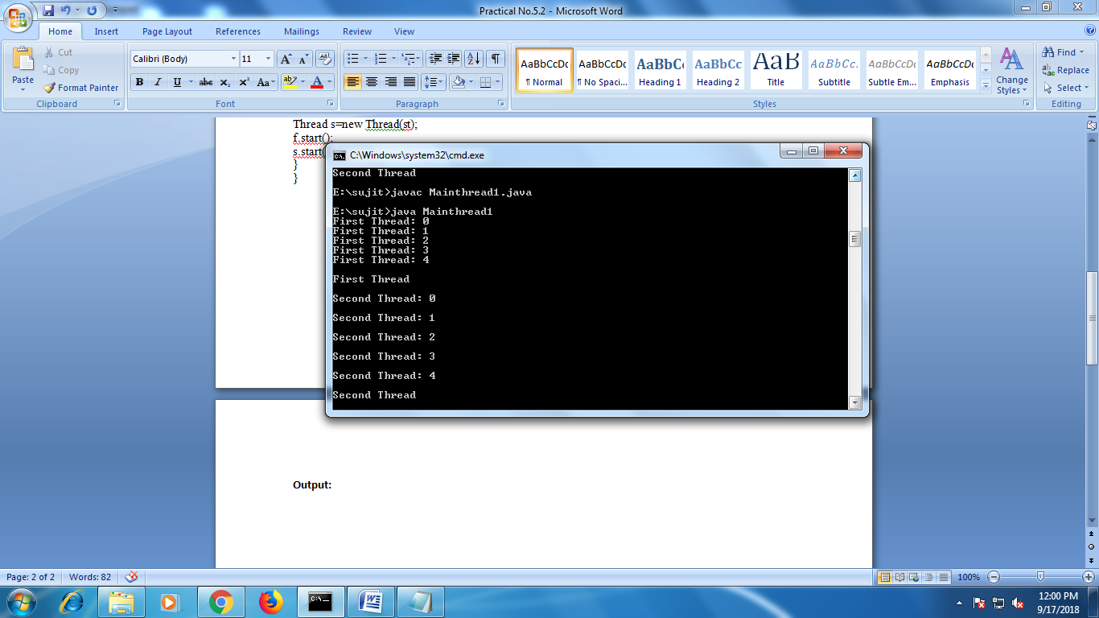

**Practical 5.3 : write a program of sleep and join methods in multithreading.**

**mainDemo.java**

import java.util.*;

class mythread extends Thread

{

public void run()

{

int i;

for(i=0;i<5;i++)

{

System.out.println("First Thread" +i);

try

{

Thread.sleep(1000);

}

catch(InterruptedException e)

{

System.out.println(e);

}

}

System.out.println("My first thread ");

}

}

class mainDemo

{

public static void main(String args[])

{

mythread m=new mythread();

m.start();

try

{

m.join();

}

catch(Exception e)

{

System.out.println(e);

}

mythread m1=new mythread();

m1.start();

mythread m2=new mythread();

m2.start();

}

}

**OUTPUT :**  
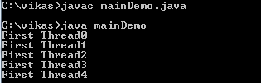

Output after first thread :

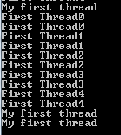

**Practical 5.4 : write a program for synchronized method in java multithreading.**

**mainD.java**

import java.util.*;

class Table

{

synchronized void print(int n)

{

int i;

System.out.println("******************Table of "+n+"*****************");

for(i=1;i<=10;i++)

{

System.out.println(n+"*"+i+"="+(n*i));

try

{

Thread.sleep(500);

}

catch(InterruptedException e)

{

System.out.println(e);

}

}

}

}

class first extends Thread

{

Table t;

first(Table t)

{

this.t=t;

}

public void run()

{

t.print(3);

}

}

class second extends Thread

{

Table t;

second(Table t)

{

this.t=t;

}

public void run()

{

t.print(7);

}

}

class third extends Thread

{

Table t;

third(Table t)

{

this.t=t;

}

public void run()

{

t.print(9);

}

}

class mainD

{

public static void main(String args[])

{

Table t1=new Table();

first f=new first(t1);

f.start();

second s=new second(t1);

s.start();

third t3=new third(t1);

t3.start();

}

}

**OUTPUT**

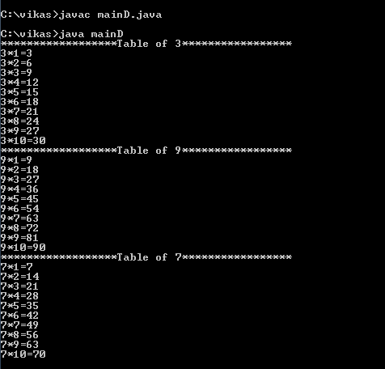

**Practical 6.1 : Write a menu driven program for read, write and copy one file to another.**

**Writefile.java**

import java.util.*;

import java.io.*;

class writeFile

{

public static void main(String args[])throws IOException

{

int ch;

Scanner sc=new Scanner(System.in);

do

{

System.out.println("Enter your choice ");

ch=sc.nextInt();

switch(ch)

{

case 1:

FileOutputStream fout=new FileOutputStream("demo.txt");

String s="welcome to java IO package program";

byte b[]=s.getBytes();

fout.write(b);

fout.close();System.out.println("write successfull");

break;

case 2:

FileInputStream fin=new FileInputStream("demo.txt");

int i;

while((i=fin.read())!=-1)

{

System.out.print((char)i);

}System.out.println("read successfull");

fin.close();

break;

case 3:

FileOutputStream fout1=new FileOutputStream("file1.txt");

FileInputStream fin1=new FileInputStream("demo.txt");

int a=0;

while((a=fin1.read())!=-1)

{

fout1.write((byte)a);

} System.out.println("copy successfull");

fin1.close();

fout1.close();

break;

}

}while(ch!=4);}}

**OUTPUT**

**Write**

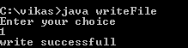

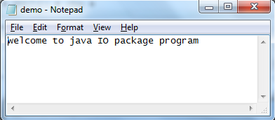

**Read**

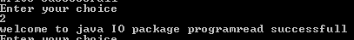

**Copy**



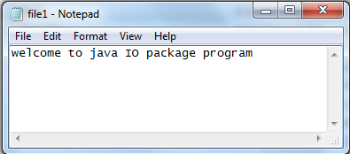

**Practical 6.2 : write a java program to copy multiple files data into one file.**

**File2.java**

import java.io.*;

import java.util.*;

class file2

{

public static void main(String args[]) throws IOException

{

FileInputStream f1=new FileInputStream("1.txt");

FileInputStream f2=new FileInputStream("2.txt");

FileOutputStream fout=new FileOutputStream("dest.txt");

SequenceInputStream sis=new SequenceInputStream(f1,f2);

int i;

while((i=sis.read())!=-1)

{

fout.write(i);

}

f1.close();

f2.close();

fout.close();

sis.close();

}

}

**Output**

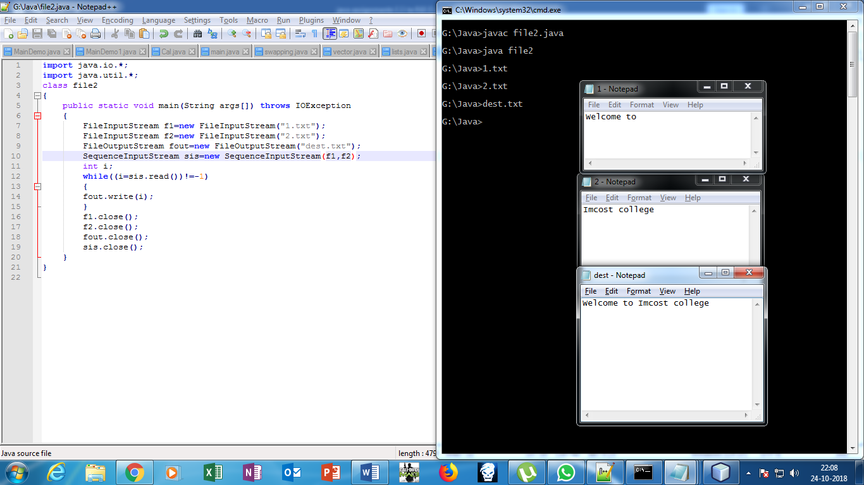

**Practical no. 6.3 : write a java program to print student details using object format.**

**Mainfile.java**

import java.util.*;

import java.io.*;

class student implements Serializable

{

String name;

int age,ph;

}

class mainfile

{

public static void main(String args[]) throws IOException

{

student s=new student();

s.name="vikas";

s.age=21;

s.ph=888;

try

{

FileOutputStream fout=new FileOutputStream("student.txt");

ObjectOutputStream obj=new ObjectOutputStream(fout);

obj.writeObject(s);

}

catch(Exception e)

{

System.out.println(e);

}

}

}

**Output on notepad :**

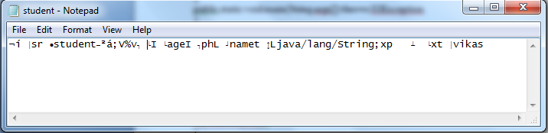

**studentData.java**

import java.util.*;

import java.io.*;

class studentData

{

public static void main(String args[]) throws IOException

{

student s=null;

try

{

FileInputStream fin=new FileInputStream("student.txt");

ObjectInputStream obj=new ObjectInputStream(fin);

s=(student)obj.readObject();

}

catch(Exception e)

{

System.out.println(e);

}

System.out.println("Student name = "+s.name);

System.out.println("age = "+s.age);

System.out.println("phone = "+s.ph);

}

}

**OUTPUT :**

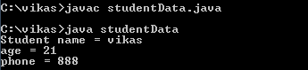

**Practical no. 7.1 : write a program to draw rectangle , oval , line , arc and text using applet.**

**Draw.java**

import java.applet.*;

import java.awt.*;

/*<applet code="draw.java" height=200 width=200></applet>*/

public class draw extends Applet

{

public void paint(Graphics g)

{

g.drawRect(20,20,40,60);

g.drawOval(50,50,100,100);

g.drawLine(150,200,250,300);

g.drawString("welcome to Applet",150,150);

g.drawArc(90,200,50,60,0,-180);

g.setColor(Color.RED);

g.fillRect(300,150, 200, 100 );

g.setColor(Color.GREEN);

g.fillOval(300,150, 200, 100 );

}

}

**OUTPUT**

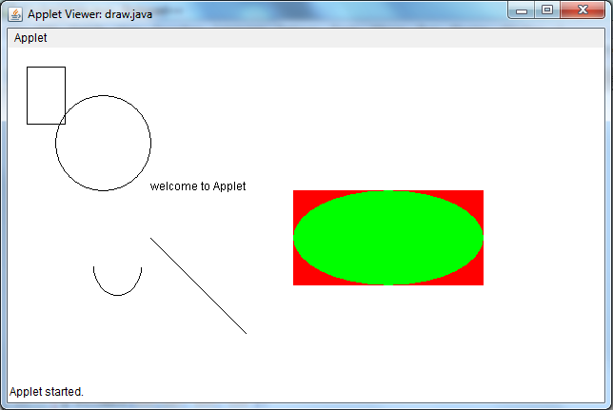

**Practical no.7.2 : write a java program to draw smiley face using applet.**

**Smiley.java**

import java.awt.*;

import java.applet.*;

/*<applet code="Smiley.java" height=200 width=200></applet>*/

public class Smiley extends Applet

{

public void paint(Graphics g)

{

g.drawString("Keep Smiling",120, 30); //text

g.drawLine(150,40,150,60);//hairs

g.drawLine(160,40,160,60); //hairs

g.drawLine(170,40,170,60); //hairs

g.drawOval(20,60,60,60); //ear

g.drawOval(240,60,60,60); //ear

g.drawLine(160,160,160,200);//nose

g.drawOval(60, 60, 200, 200);//main face

g.drawOval(85,120,60,40);//eye

g.drawOval(180,120,60,40);//eye

g.drawArc(120,180,80,50,0,-180);//smile

}

}

**OUTPUT**

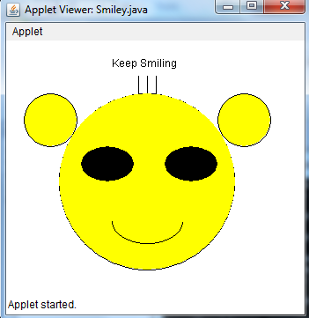

**Practical no.7.3 :write a program to print rectangle , oval and line using for loop.**

**React.java**

import java.awt.*;

import java.applet.*;

/*<applet code="react.java" height=200 width=200></applet>*/

public class react extends Applet

{

public void paint(Graphics g)

{

for(int i=0;i<250;i++)

{

Color c1=new Color(30-i,200-i,80-i);

g.setColor(c1);

g.drawRect(250+i,250+i,100+i,100+i);

g.drawOval(100+i,100+i,50+i,50+i);

g.drawLine(50+i,20+i,10+i,10+i);

}

}

}

**OUTPUT**

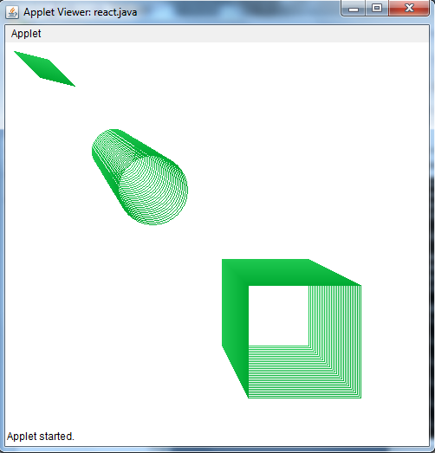

**Practical no.7.4 : write a java program to print font with background;**

**Font.java**

import java.awt.*;

import java.applet.*;

/*<applet code="font.java" height=200 width=200>

</applet>

*/

public class font extends Applet

{

public void init()

{

setBackground(Color.PINK);

Font f=new Font("ARIAL",Font.BOLD|Font.ITALIC|Font.UNDERLINE,40);

setFont(f);

}

public void paint(Graphics g)

{

g.drawString("welcome to java",50,50);

}

}

**OUTPUT**

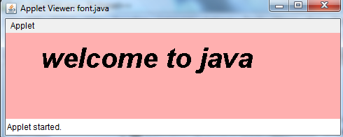

**Practical no.7.5 : write a java program to print all components of awt.**

import java.awt.*;

import java.applet.*;

/*<applet code="components.java" height=200 width=200></applet>*/

public class components extends Applet

{

Button b1,b2;

Label l1,l2;

Checkbox c1,c2,r1,r2;

CheckboxGroup rgb;

Choice ch1,ch2;

List L1,L2;

TextArea a1,a2;

TextField f1;

public void init()

{

setBackground(Color.YELLOW);

b1=new Button("OK");

b2=new Button("submit");

add(b1);

add(b2);

l1=new Label("hello");

l2=new Label("bye bye");

add(l1);

add(l2);

c1=new Checkbox("MMS",true);

c2=new Checkbox("MCA",false);

add(c1);

add(c2);

rgb=new CheckboxGroup();

r1=new Checkbox("Male",true,rgb);

r2=new Checkbox("FeMale",false,rgb);

add(r1);

add(r2);

ch1=new Choice();

ch1.add("Mumbai");

ch1.add("Delhi");

ch1.add("chennai");

ch1.add("goa");

add(ch1);

ch2=new Choice();

ch2.add("Vada Pav");

ch2.add("Chat");

ch2.add("Idli ");

ch2.add("fish");

add(ch2);

L1=new List();

L1.addItem("Dairy Milk");

L1.addItem("Perk");

L1.addItem("Munch");

add(L1);

L2=new List();

L2.addItem("cpp");

L2.addItem("Perl");

L2.addItem("java");

add(L2);

String s="hello world";

a1=new TextArea(s,10,30);

a2=new TextArea(10,30);

add(a1);

add(a2);

f1=new TextField(10);

f1.setEchoChar('*');

add(f1);

}

}

**OUTPUT**

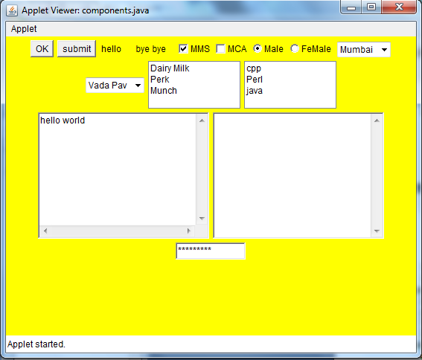

**7.6 Write a program to add, multiplication, subtraction using applet.**

import java.awt.*;

import java.applet.*;

/*<applet code="calc.java"height=500 width=500>

</applet>*/

public class calc extends Applet

{

Label l1,l2;

TextField t1,t2;

public void init()

{

l1=new Label("Number1");

l2=new Label("Number2");

t1=new TextField(10);

t2=new TextField(10);

t1.setText("0");

t1.setText("0");

add(l1);

add(t1);

add(l2);

add(t2);

}

public void paint(Graphics g)

{

int num1=0;

int num2=0;

int add,mul,sub;

String s1,s2;

try

{

s1=t1.getText();

s2=t2.getText();

num1=Integer.parseInt(s1);

num2=Integer.parseInt(s2);

}

catch(Exception e)

{

System.out.println(e);

}

add=num1+num2;

mul=num1*num2;

sub=num1-num2;

String str1="Addition of:"+ String.valueOf(add);

g.drawString(str1,150,100);

String str2="Multiplication of:"+ String.valueOf(mul);

g.drawString(str2,150,200);

String str3="subtraction of:"+ String.valueOf(sub);

g.drawString(str3,150,140);

}

public boolean action(Event e,Object ob)

{

repaint();

return true;

}

}

**Output:**

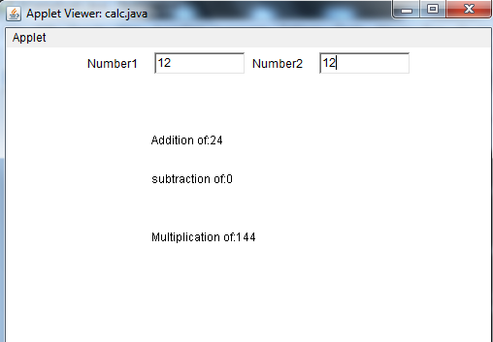

**7.7 Write a program to create buttons using GridLayout in JFrame.**

import javax.swing.*;

import java.awt.*;

public class Jbutton

{

Jbutton()

{

JFrame f=new JFrame("GridLayoutDemo");

JButton b1=new JButton("ONE");

JButton b2=new JButton("TWO");

JButton b3=new JButton("THREE");

JButton b4=new JButton("FOUR");

JButton b5=new JButton("Five");

JButton b6=new JButton("SIX");

JButton b7=new JButton("SEVEN");

JButton b8=new JButton("EIGHT");

JButton b9=new JButton("NINE");

f.add(b1);

f.add(b2);

f.add(b3);

f.add(b4);

f.add(b5);

f.add(b6);

f.add(b7);

f.add(b8);

f.add(b9);

f.setLayout(new GridLayout(3,3));

f.setSize(200,200);

f.setVisible(true);

f.setDefaultCloseOperation(JFrame.EXIT_ON_CLOSE);

}

public static void main(String args[])

{

new Jbutton();

}

}

**Output:**

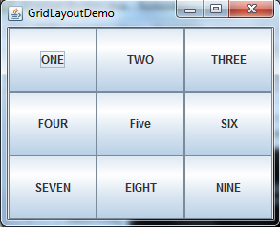

**7.8 write a program to add menu and menubar.**

import javax.swing.*;

import java.awt.*;

public class MenuDemo

{

public MenuDemo()

{

JFrame f=new JFrame();

MenuBar mb=new MenuBar();

f.setMenuBar(mb);

Menu m1=new Menu("Festival");

mb.add(m1);

MenuItem mt1=new MenuItem("Diwali");

MenuItem mt2=new MenuItem("Navratri");

MenuItem mt3=new MenuItem("Holi");

m1.add(mt1);

m1.add(mt2);

m1.add(mt3);

Menu m11=new Menu("color");

mb.add(m11);

MenuItem mt11=new MenuItem("pink");

MenuItem mt21=new MenuItem("white");

MenuItem mt31=new MenuItem("black");

m11.add(mt11);

m11.add(mt21);

m11.add(mt31);

f.setTitle("Frame");

f.setSize(200,200);

f.setVisible(true);

f.setDefaultCloseOperation(JFrame.EXIT_ON_CLOSE);

}

public static void main(String args[])

{

new MenuDemo();

}

}

**Output:**

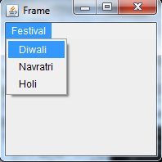

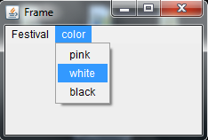

**Practical No. 7.9 :- Write a program to demonstrate JButton using Action Listener.**

**Source Code:**

import java.awt.*;

import javax.swing.*;

import java.awt.event.*;

public class Jokes

{

JFrame f;

public static void main(String args[])

{

Jokes j=new Jokes();

}

public Jokes()

{

f=new JFrame();

JButton b=new JButton("Click ME");

b.addActionListener(new myclick());

f.add(b);

f.setSize(200,200);

f.setVisible(true);

f.setDefaultCloseOperation(JFrame.EXIT_ON_CLOSE);

}

class myclick implements ActionListener

{

public void actionPerformed(ActionEvent e)

{

JOptionPane.showMessageDialog(f,"Santa was caught for speeding and went before the judge.The judge: What'll you take 30 days or Rs 3000.Santa: I

think I'll take the money");

}

}

}

**Output:**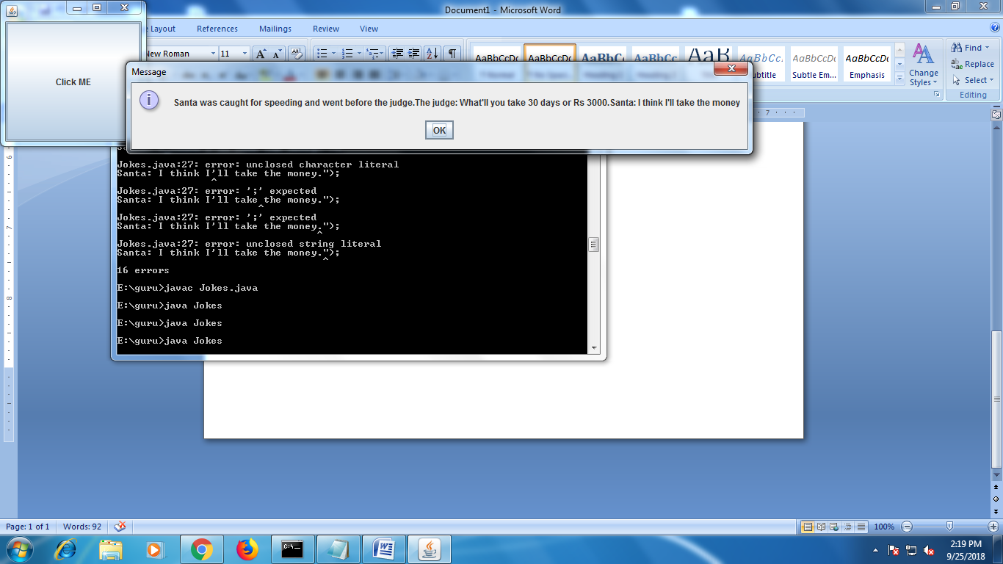

**Practical No. 7.10:- Write a program for Comobo Box.**

**Source Code:**

import java.awt.*;

import javax.swing.*;

import java.awt.event.*;

import java.applet.*;

/*<applet code="combodemo.java" width=200 height=200></applet> */

public class combodemo extends JApplet implements ItemListener

{

JLabel l1;

ImageIcon pic1,pic2,pic3,pic4,pic5;

public void init()

{

Container cp=getContentPane();

cp.setLayout(new FlowLayout());

l1=new JLabel("INDIAN NAVY");

cp.add(l1);

JComboBox cb=new JComboBox();

cb.addItem("pic1");

cb.addItem("pic2");

cb.addItem("pic3");

cb.addItem("pic4");

cb.addItem("pic5");

cb.addItemListener(this);

cp.add(cb);

l1=new JLabel(new ImageIcon("pic1.jpg"));

cp.add(l1);

}

public void itemStateChanged(ItemEvent e)

{

String s=(String)e.getItem();

l1.setIcon(new ImageIcon(s+".jpg"));

}

}

**Output:**

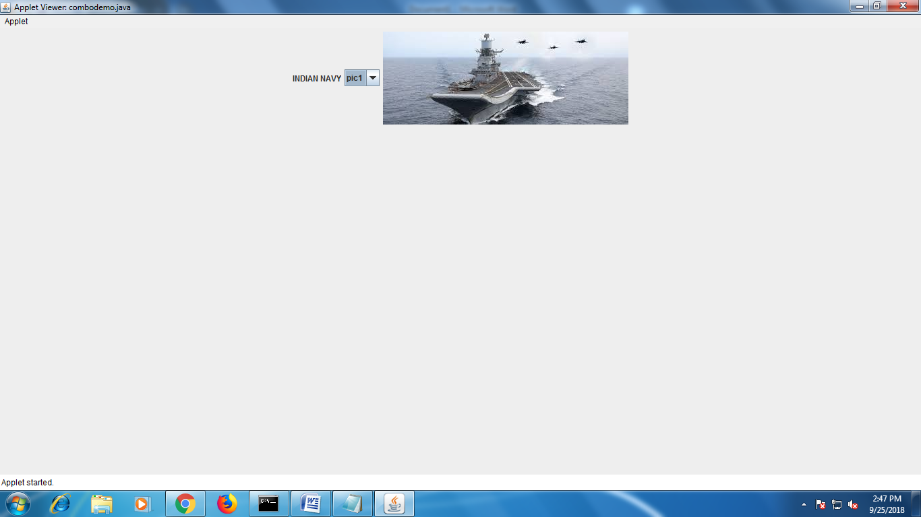

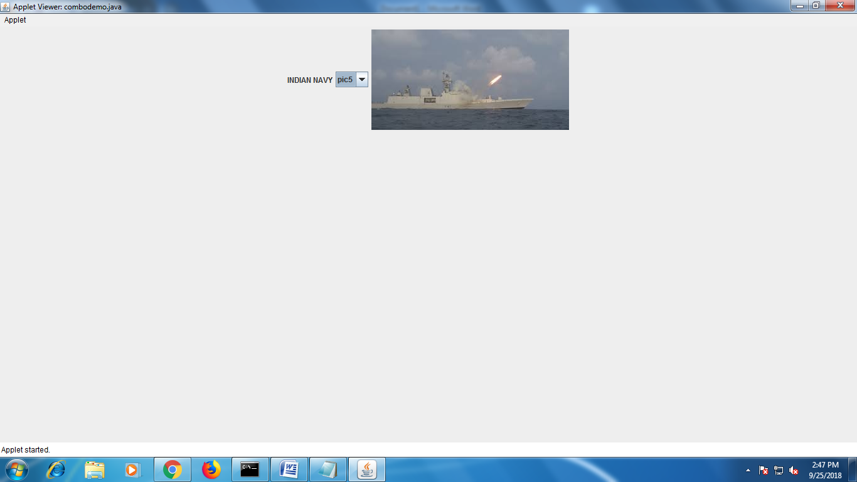

**Practical No. 8.1:- Write a program for creating table using JDBC.**

**Source Code:**

import java.sql.*;

class ct

{

public static void main(String args[])

{

try

{

Class.forName("sun.jdbc.odbc.JdbcOdbcDriver");

Connection con=DriverManager.getConnection("jdbc:odbc:test");

Statement st=con.createStatement();

String s="create table emp(eno number,ename varchar(10))";

st.executeUpdate(s);

System.out.println("Table created!!");

st.close();

con.close();

}

catch(Exception e)

{

System.out.println(e);

}

}

}

**Output:**

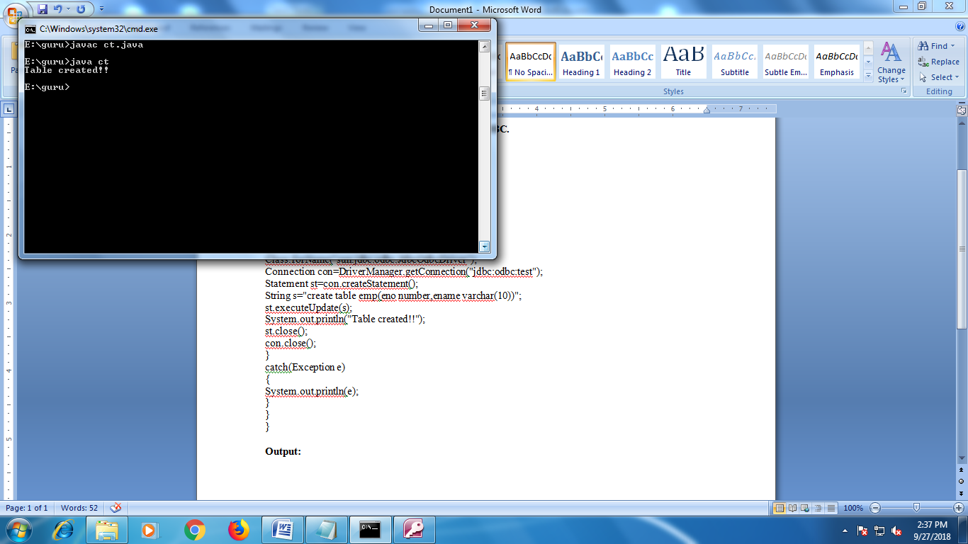

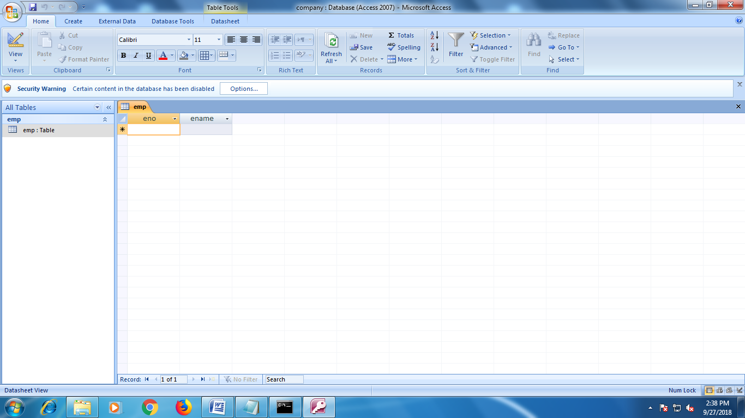

**Practical No. 8.2:- Write a program for insert records in table using JDBC.**

**Source Code:**

import java.sql.*;

import java.util.*;

class it

{

public static void main(String args[])

{

char ch;

Scanner sc=new Scanner(System.in);

try

{

Class.forName("sun.jdbc.odbc.JdbcOdbcDriver");

Connection con=DriverManager.getConnection("jdbc:odbc:test");

Statement st=con.createStatement();

do

{

System.out.println("Enter Employee ID: ");

int id=sc.nextInt();

System.out.println("\nEnter Employee Name: ");

String na=sc.next();

String s="insert into emp values('"+id+"','"+na+"')";

st.executeUpdate(s);

System.out.println("\nRecord Inserted!!");

System.out.println("\nDo you want to continue[Yes/No]: ");

ch=sc.next().charAt(0);

}while(ch=='Y' || ch=='y');

con.close();

st.close();

}

catch(Exception e)

{

System.out.println(e);

}

}

}

**Output:**

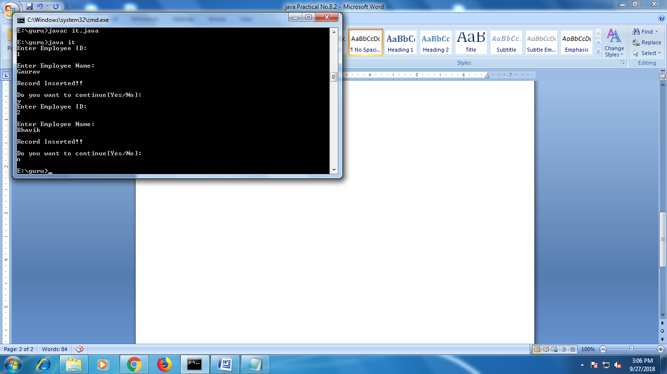

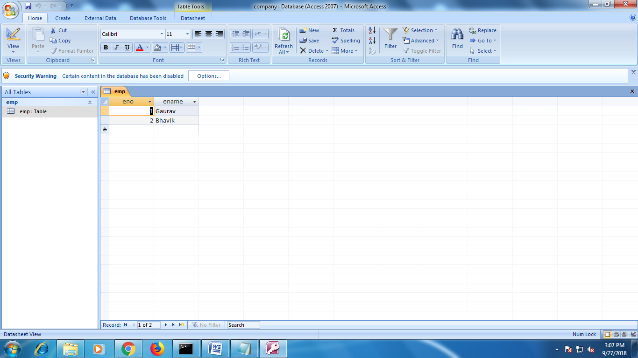

**Practical No. 8.3:- Write a program to connect applet to database.**

**Source Code:**

import java.sql.*;

import java.awt.*;

import java.awt.event.*;

class student extends Frame implements ActionListener

{

Frame f;

Label l1,l2;

TextField t1,t2;

Button b1,b2,b3,b4;

Connection con;

Statement st;

ResultSet rs;

student()

{

try

{

f=new Frame();

f.setLayout(null);

f.setVisible(true);

f.setSize(500,500);

l1=new Label("Roll No.:");

l1.setBounds(20,20,50,50);

f.add(l1);

l2=new Label("Name:");

l2.setBounds(20,100,50,50);

f.add(l2);

t1=new TextField(50);

t1.setBounds(150,20,50,50);

f.add(t1);

t2=new TextField(50);

t2.setBounds(150,100,50,50);

f.add(t2);

b1=new Button("Insert");

b1.setBounds(50,150,50,100);

f.add(b1);

b1.addActionListener(this);

b2=new Button("Delete");

b2.setBounds(100,150,50,100);

f.add(b2);

b2.addActionListener(this);

b3=new Button("Update");

b3.setBounds(150,150,50,100);

f.add(b3);

b3.addActionListener(this);

b4=new Button("Exit");

b4.setBounds(200,150,50,100);

f.add(b4);

b4.addActionListener(this);

Class.forName("sun.jdbc.odbc.JdbcOdbcDriver");

con=DriverManager.getConnection("jdbc:odbc:stu");

st=con.createStatement();

}

catch(Exception e)

{

System.out.println(e);

}

}

public void actionPerformed(ActionEvent ae)

{

try

{

if(ae.getSource()==b1)

{

String s1="insert into stud(Roll,Name) values('"+t1.getText()+"','"+t2.getText()+"')";

st.executeUpdate(s1);

System.out.println("Inserted values: "+s1);

rs=st.executeQuery("select * from stud");

t1.setText("0");

t2.setText("0");

}

else if(ae.getSource()==b2)

{

String s2="delete from stud where Roll="+t1.getText();

st.executeUpdate(s2);

System.out.println("Values Deleted!!!");

}

else if(ae.getSource()==b3)

{

String s3="update stud set Name='"+t2.getText()+"' where Roll="+t1.getText();

st.executeUpdate(s3);

System.out.println("Update Successfully!!!");

}

else if(ae.getSource()==b4)

{

f.dispose();

st.close();

con.close();

}

}

catch(Exception e)

{

System.out.println(e);

}

}

public static void main(String args[])

{

student s=new student();

}

}

**Output:**

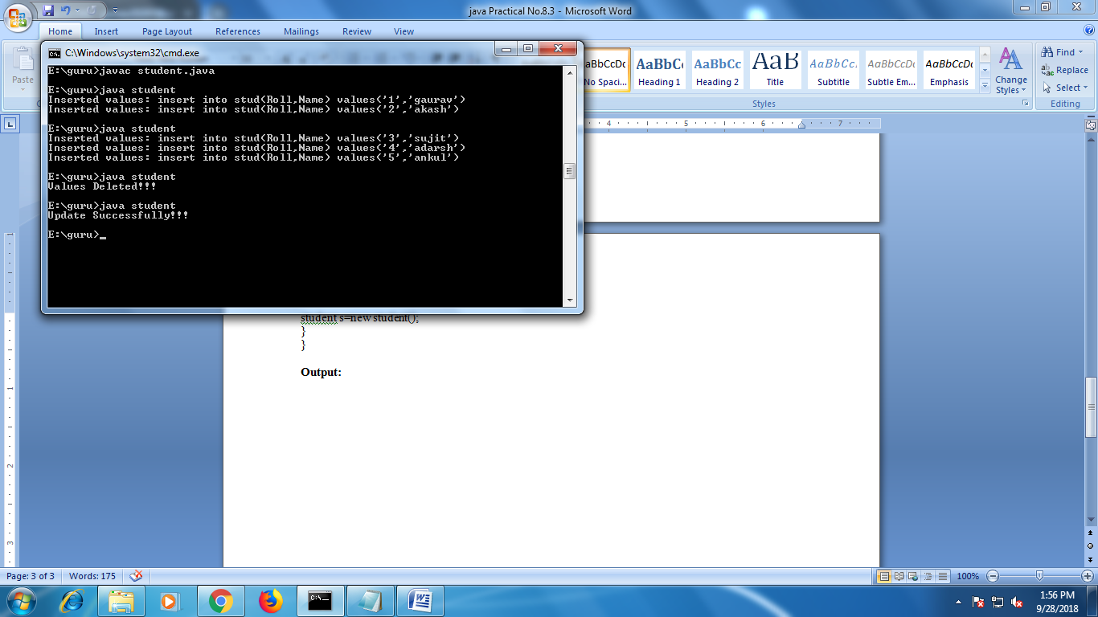

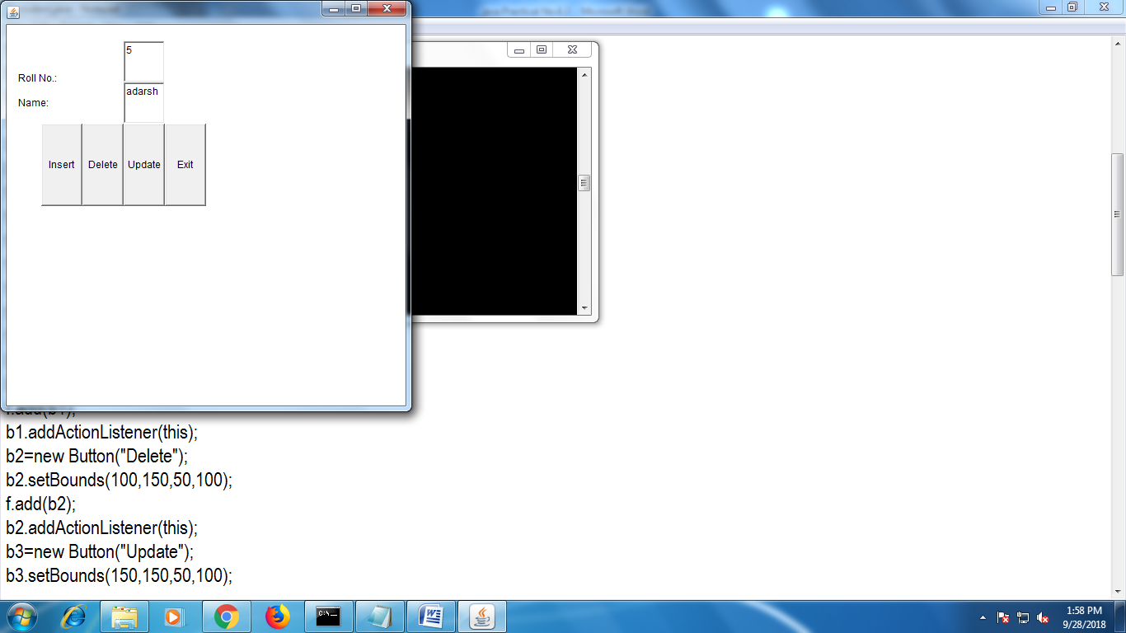

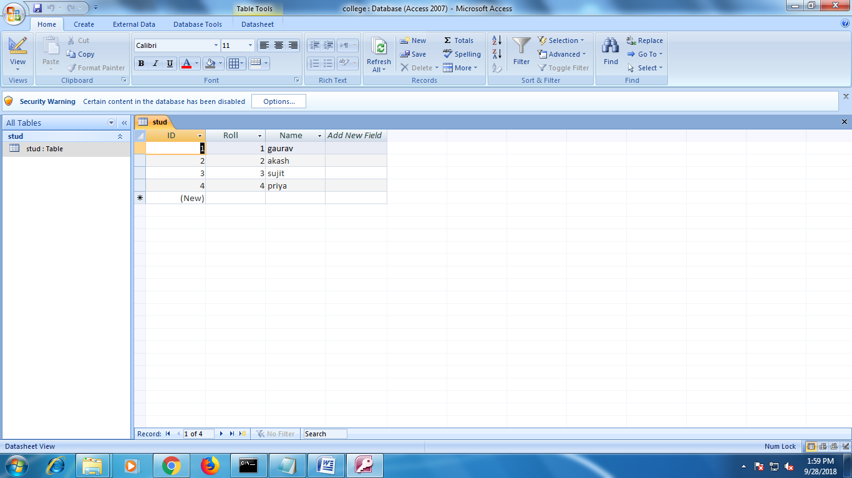

**Practical No. 9.1:- Write a program to find gross salary using get method.**

**Source Code:**

**Index.html:-**

<!DOCTYPE html>

<!--

To change this license header, choose License Headers in Project Properties.

To change this template file, choose Tools | Templates

and open the template in the editor.

-->

<html>

<head>

<title>TODO supply a title</title>

<meta charset="UTF-8">

<meta name="viewport" content="width=device-width">

</head>

<body>

<form action="calculate" method="get">

Enter BS: <input type="text" name="t1"><br/>

Enter TA: <input type="text" name="t2"></br>

Enter DA: <input type="text" name="t3"></br>

Enter HRA: <input type="text" name="t4"></br>

Enter TAX: <input type="text" name="t5"></br>

<input type="submit" value="Submit">

<input type="reset" value="Reset">

</form>

</body>

</html>

**Calculate.java:-**

public class calculate extends HttpServlet {

protected void processRequest(HttpServletRequest request, HttpServletResponse response)

throws ServletException, IOException {

response.setContentType("text/html;charset=UTF-8");

try (PrintWriter out = response.getWriter()) {

int bs=Integer.parseInt(request.getParameter("t1"));

int ta=Integer.parseInt(request.getParameter("t2"));

int da=Integer.parseInt(request.getParameter("t3"));

int hra=Integer.parseInt(request.getParameter("t4"));

int tax=Integer.parseInt(request.getParameter("t5"));

float gross=bs+ta+da+hra-tax;

out.println("Gross Salary: "+gross);

}

}

**Output:**

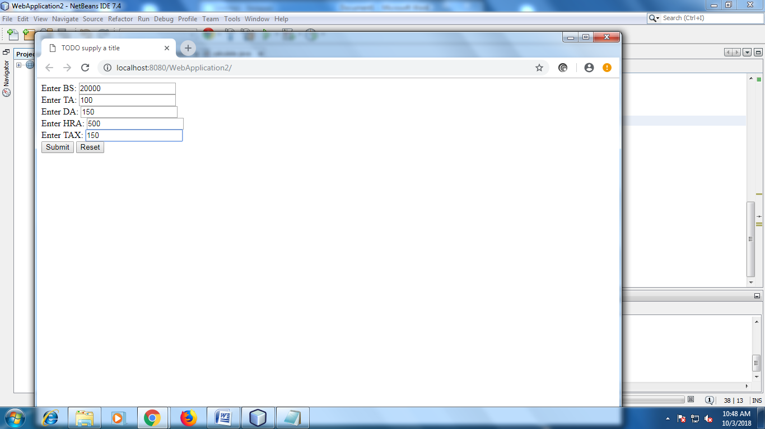

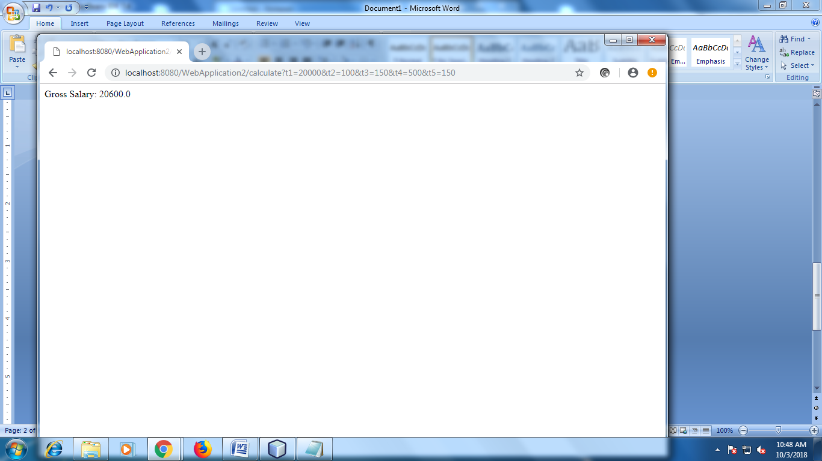

**Practical No. 9.2:- Write a program to generate voter id using post method.**

**Source Code:**

**Index.html:-**

<html>

<head>

<title>TODO supply a title</title>

<meta charset="UTF-8">

<meta name="viewport" content="width=device-width">

</head>

<body>

<form action="servlet1" method="post">

Enter Name:<input type="text" name="t1"><br/><br/>

Enter Age:<input type="text" name="t2"><br/><br/>

Enter Address:<input type="text" name="t3"><br/><br/>

Select Gender:Male<input type="radio" name="r1" value="Male" checked="true">

Female<input type="radio" value="Female" name="r1">

Others<input type="radio" value="Others" name="r1"><br/><br/>

<input type="submit" value="Submit">

<input type="reset" value="Reset">

</form>

</body>

</html>

**Servlet1.java:-**

public class servlet1 extends HttpServlet {

/**

* Processes requests for both HTTP <code>GET</code> and <code>POST</code>

* methods.

*

* @param request servlet request

* @param response servlet response

* @throws ServletException if a servlet-specific error occurs

* @throws IOException if an I/O error occurs

*/

protected void processRequest(HttpServletRequest request, HttpServletResponse response)

throws ServletException, IOException {

response.setContentType("text/html;charset=UTF-8");

try (PrintWriter out = response.getWriter()) {

String name=request.getParameter("t1");

int age=Integer.parseInt(request.getParameter("t2"));

String add=request.getParameter("t3");

String gen=request.getParameter("r1");

if(age>=18)

{

RequestDispatcher rs=request.getRequestDispatcher("servlet2");

rs.forward(request, response);

}

else

{

out.println("Sorry you are not eligible for voting");

RequestDispatcher rs=request.getRequestDispatcher("index.html");

rs.include(request,response);

}

}

}

// <editor-fold defaultstate="collapsed" desc="HttpServlet methods. Click on the + sign on the left to edit the code.">

/**

* Handles the HTTP <code>GET</code> method.

*

* @param request servlet request

* @param response servlet response

* @throws ServletException if a servlet-specific error occurs

* @throws IOException if an I/O error occurs

*/

@Override

protected void doGet(HttpServletRequest request, HttpServletResponse response)

throws ServletException, IOException {

processRequest(request, response);

}

/**

* Handles the HTTP <code>POST</code> method.

*

* @param request servlet request

* @param response servlet response

* @throws ServletException if a servlet-specific error occurs

* @throws IOException if an I/O error occurs

*/

@Override

protected void doPost(HttpServletRequest request, HttpServletResponse response)

throws ServletException, IOException {

processRequest(request, response);

}

/**

* Returns a short description of the servlet.

*

* @return a String containing servlet description

*/

@Override

public String getServletInfo() {

return "Short description";

}// </editor-fold>

}

**Servlet2.java:-**

public class servlet2 extends HttpServlet {

/**

* Processes requests for both HTTP <code>GET</code> and <code>POST</code>

* methods.

*

* @param request servlet request

* @param response servlet response

* @throws ServletException if a servlet-specific error occurs

* @throws IOException if an I/O error occurs

*/

protected void processRequest(HttpServletRequest request, HttpServletResponse response)

throws ServletException, IOException {

response.setContentType("text/html;charset=UTF-8");

try (PrintWriter out = response.getWriter()) {

String name = request.getParameter("t1");

int age=Integer.parseInt(request.getParameter("t2"));

String address = request.getParameter("t3");

String gender = request.getParameter("r1");

out.println("Congrats you are eligible for voting");

out.println("Name : " +name);

out.println("age : " +age);

out.println("Address : " +address);

out.println("gender : " +gender);

}

}

// <editor-fold defaultstate="collapsed" desc="HttpServlet methods. Click on the + sign on the left to edit the code.">

/**

* Handles the HTTP <code>GET</code> method.

*

* @param request servlet request

* @param response servlet response

* @throws ServletException if a servlet-specific error occurs

* @throws IOException if an I/O error occurs

*/

@Override

protected void doGet(HttpServletRequest request, HttpServletResponse response)

throws ServletException, IOException {

processRequest(request, response);

}

/**

* Handles the HTTP <code>POST</code> method.

*

* @param request servlet request

* @param response servlet response

* @throws ServletException if a servlet-specific error occurs

* @throws IOException if an I/O error occurs

*/

@Override

protected void doPost(HttpServletRequest request, HttpServletResponse response)

throws ServletException, IOException {

processRequest(request, response);

}

/**

* Returns a short description of the servlet.

*

* @return a String containing servlet description

*/

@Override

public String getServletInfo() {

return "Short description";

}// </editor-fold>

}

**Output:**

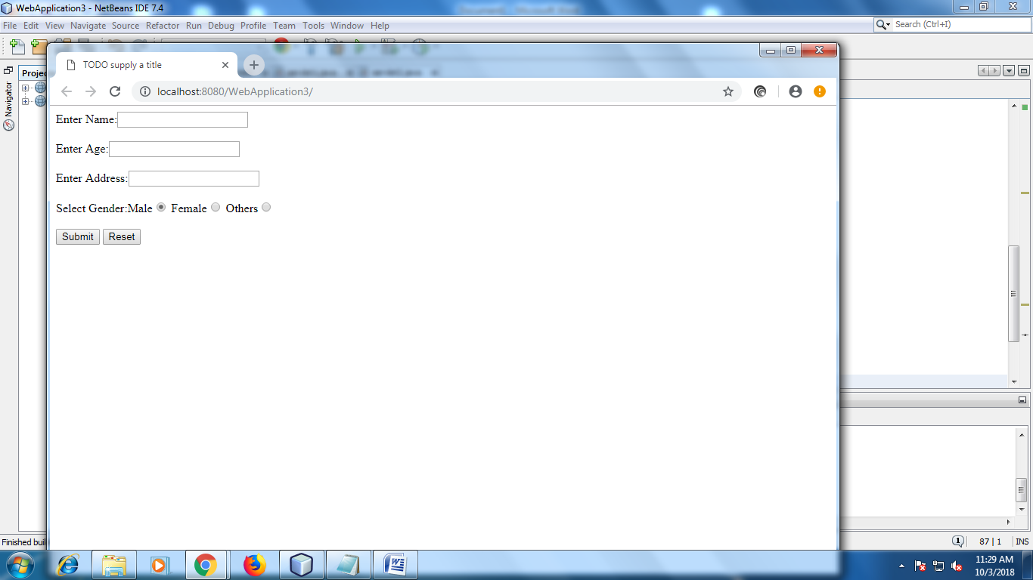

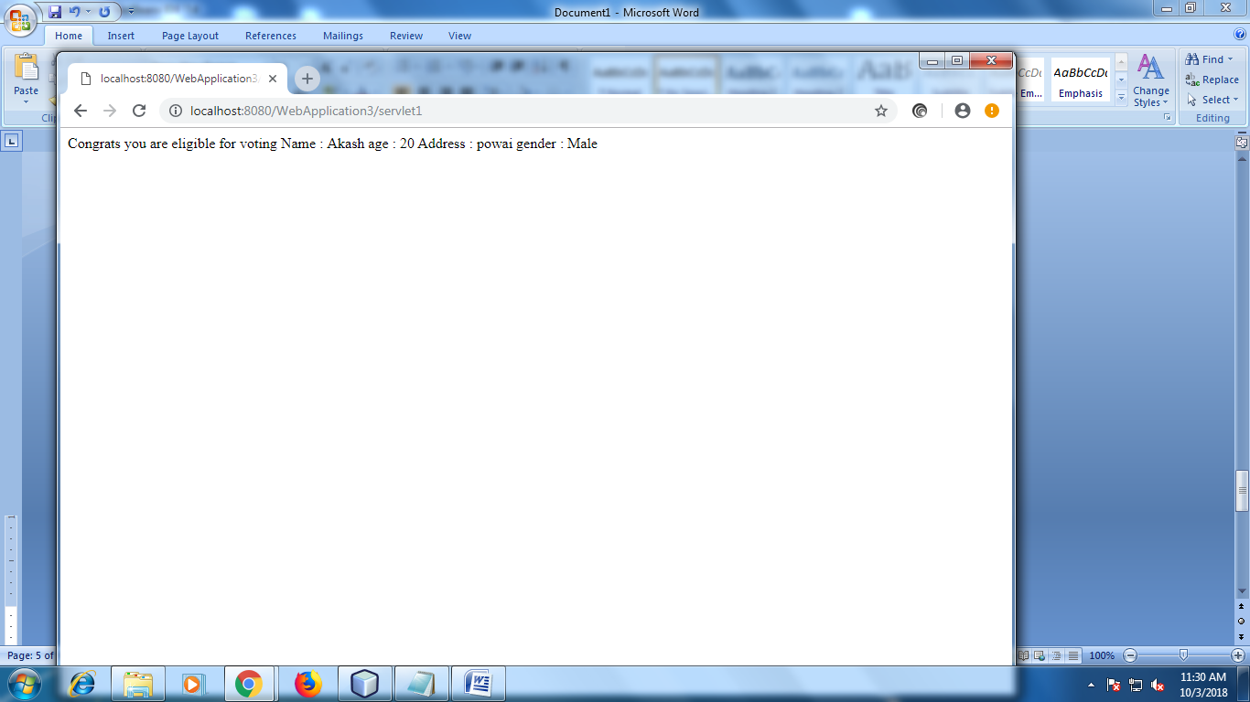

**Practical No. 9.3:- Write a program for different pattern in JSP page.**

**Source Code:**

**Jsp1.jsp:-**

<%--

Document : jsp1

Created on : Oct 3, 2018, 6:50:20 AM

Author : acer

--%>

<%@page contentType="text/html" pageEncoding="UTF-8"%>

<!DOCTYPE html>

<html>

<head>

<meta http-equiv="Content-Type" content="text/html; charset=UTF-8">

<title>JSP Page</title>

</head>

<body>

<%

for(int i=0;i<=10;i++)

{

out.println("<br>");

for(int j=1;j<=i;j++)

{

out.println(+i);

}

}

%>

<form action="jsp2.jsp">

<input type="submit" value="Next">

</form>

</body>

</html>

**Jsp2.jsp:-**

<%--

Document : jsp2

Created on : Oct 3, 2018, 7:13:40 PM

Author : acer

--%>

<%@page contentType="text/html" pageEncoding="UTF-8"%>

<!DOCTYPE html>

<html>

<head>

<meta http-equiv="Content-Type" content="text/html; charset=UTF-8">

<title>JSP Page</title>

</head>

<body>

<%

for(int i=0;i<=10;i++)

{

out.println("<br>");

for(int j=1;j<=i;j++)

{

out.println(+j);

}

}

%>

<form action="jsp3.jsp">

<input type="submit" value="Next">

</form><br/><br/>

<form action="jsp1.jsp">

<input type="submit" value="Privious">

</form>

</body>

</html>

**Jsp3.jsp:-**

<%--

Document : jsp5

Created on : Oct 3, 2018, 7:21:43 PM

Author : acer

--%>

<%@page contentType="text/html" pageEncoding="UTF-8"%>

<!DOCTYPE html>

<html>

<head>

<meta http-equiv="Content-Type" content="text/html; charset=UTF-8">

<title>JSP Page</title>

</head>

<body>

<%

for(int i = 5; i >= 1; --i)

{

for(int j = 1; j <= i; ++j)

{

out.print(+j);

}

out.println("<br>");

}

%>

<form action="jsp4.jsp">

<input type="submit" value="Privious">

</form>

</body>

</html>

**Jsp4.jsp:-**

<%--

Document : jsp4

Created on : Oct 3, 2018, 7:19:16 PM

Author : acer

--%>

<%@page contentType="text/html" pageEncoding="UTF-8"%>

<!DOCTYPE html>

<html>

<head>

<meta http-equiv="Content-Type" content="text/html; charset=UTF-8">

<title>JSP Page</title>

</head>

<body>

<%

for(int i=1;i<=5;++i)

{

for(int j = 1; j <= i; ++j)

{

out.print("* ");

}

out.println("<br>");

}

%>

<form action="jsp5.jsp">

<input type="submit" value="Next">

</form><br/><br/>

<form action="jsp3.jsp">

<input type="submit" value="Privious">

</form>

</body>

</html>

**Jsp5.jsp:-**

<%--

Document : jsp5

Created on : Oct 3, 2018, 7:21:43 PM

Author : acer

--%>

<%@page contentType="text/html" pageEncoding="UTF-8"%>

<!DOCTYPE html>

<html>

<head>

<meta http-equiv="Content-Type" content="text/html; charset=UTF-8">

<title>JSP Page</title>

</head>

<body>

<%

for(int i = 5; i >= 1; --i)

{

for(int j = 1; j <= i; ++j)

{

out.print(+j);

}

out.println("<br>");

}

%>

<form action="jsp4.jsp">

<input type="submit" value="Privious">

</form>

</body>

</html>

**Output:**

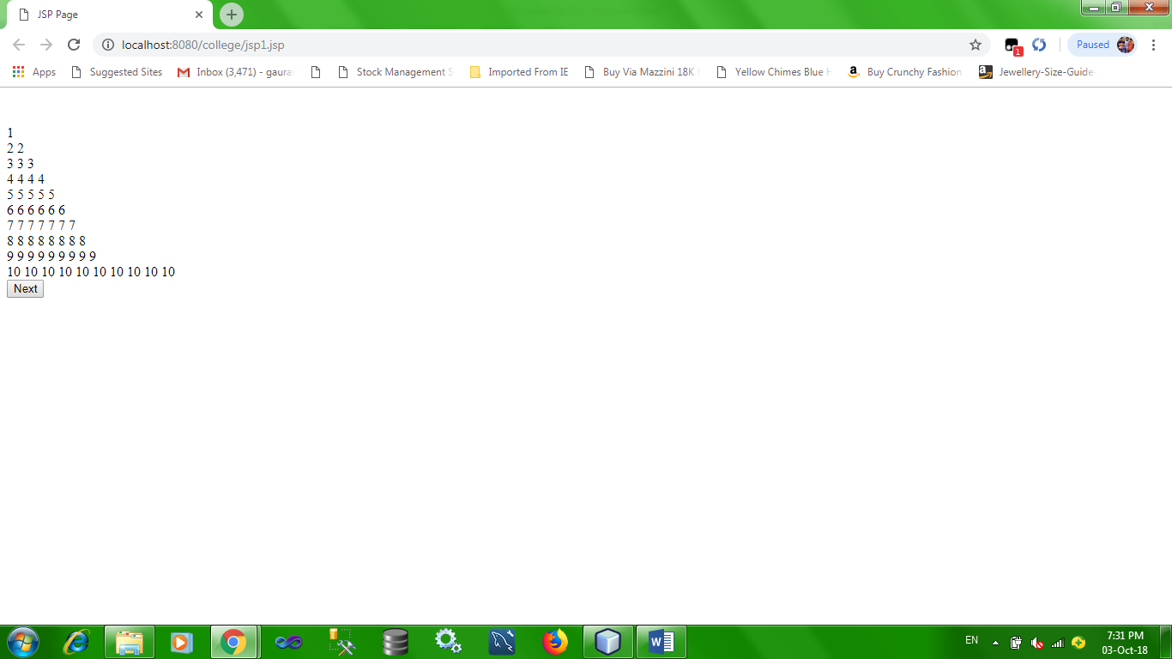

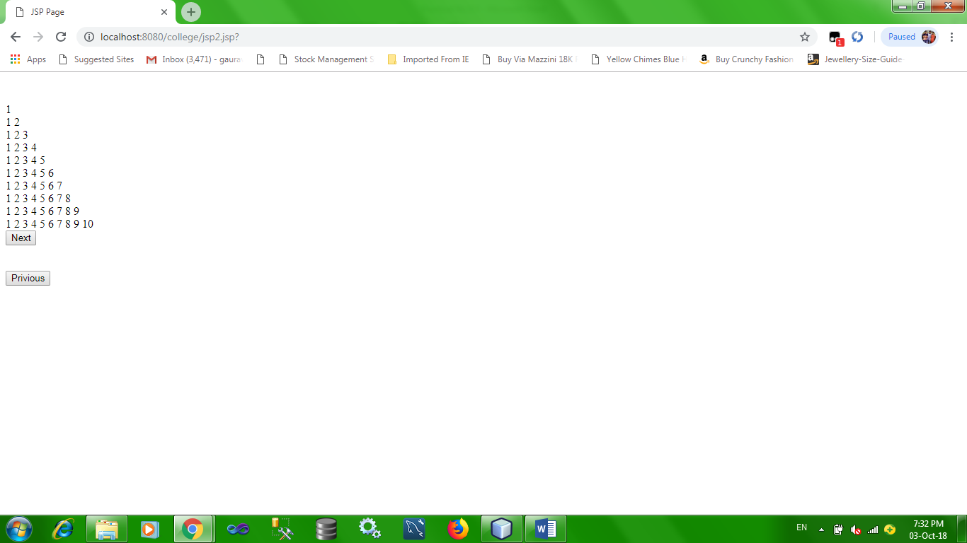

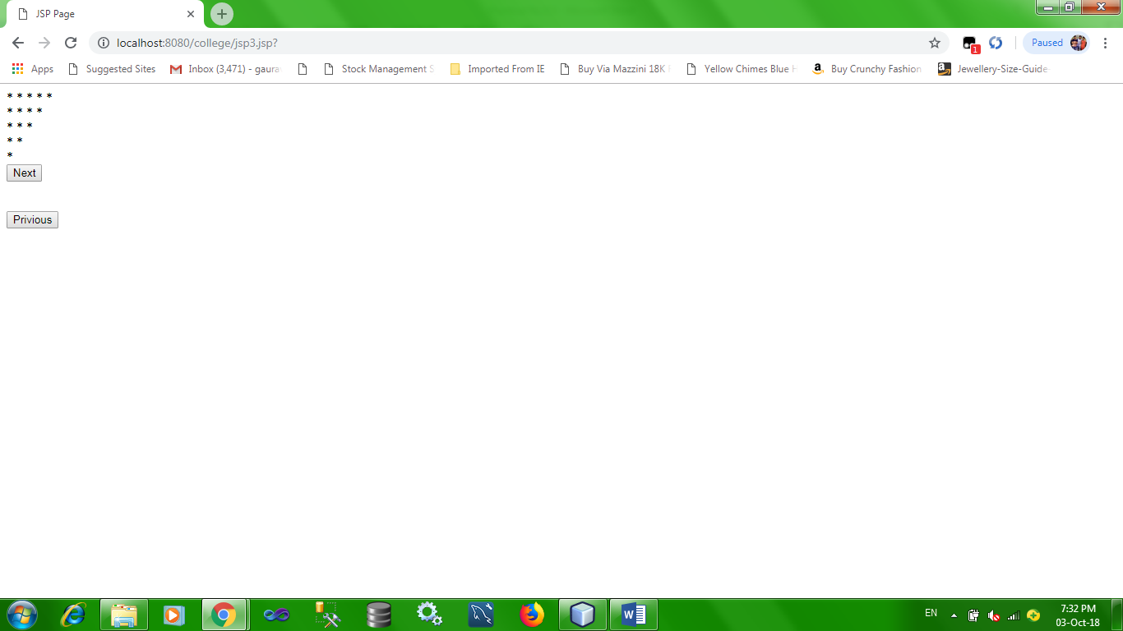

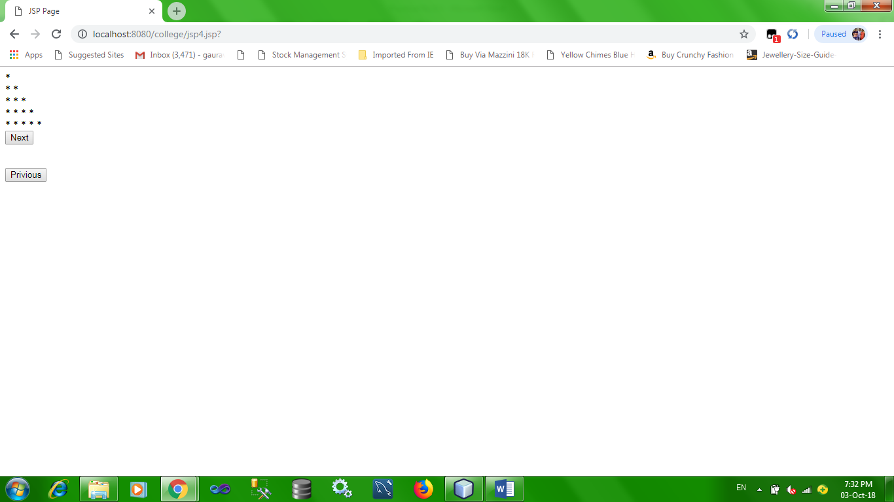

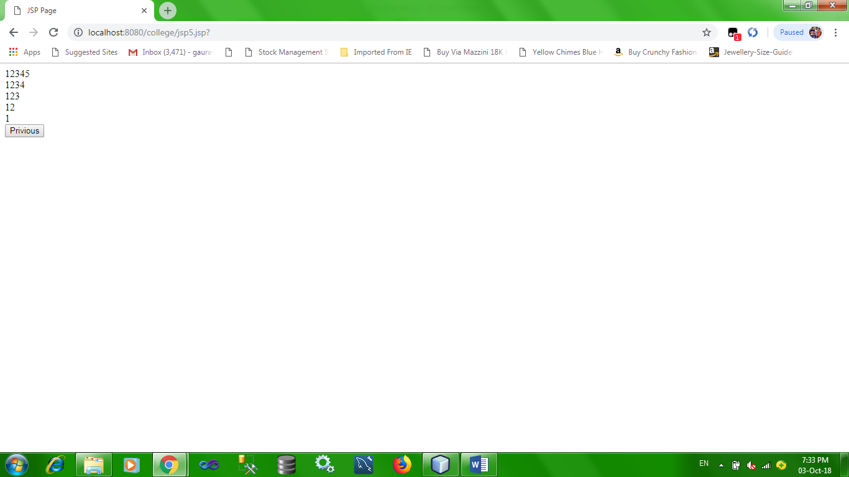

**Practical No. 9.4:- Write a program of servlet currency converter.**

**Source Code:**

<%--

Document : currency

Created on : Oct 4, 2018, 1:37:33 PM

Author : Student

--%

<%@page contentType="text/html" pageEncoding="UTF-8"%>

<!DOCTYPE html>

<html>

<head>

<meta http-equiv="Content-Type" content="text/html; charset=UTF-8">

<title>JSP Page</title>

</head>

<body>

<form action="Currency" method="POST" ALIGN="CENTER">

<h1>Currency converter</h1>

<TABLE ALIGN="CENTER" BORDER="2" bgcolor="sky blue">

<TR><TD> Enter amount to convert </TD> <TD><input type="text" name="amt" size="50"></TD></TR>

<TR><TD>Select country </TD> <TD> from : <select name="currencyFrom">select currency

<option value="" selected></option>

<option value="1">INDIA (IND)</option>

<option value="73">USA (america)</option>

</select>

To : <select name="currency2">select currency

<option value="" selected></option>

<option value="1">INDIA (IND)</option>

<option value="73">USA (america)</option>

</select>

</TD></TR>

<TR><TD COLSPAN="2">&nbsp;&nbsp;&nbsp;&nbsp;&nbsp;&nbsp;&nbsp;&nbsp;&nbsp;&nbsp;&nbsp;&nbsp;&nbsp;

&nbsp;&nbsp;&nbsp;&nbsp;&nbsp;&nbsp;&nbsp;

&nbsp;&nbsp;&nbsp;&nbsp;&nbsp;

<input type="submit" value="convert"></TD></TR>

</TABLE>

</form>

</body>

</html>

**Currency.java:-**

try (PrintWriter out = response.getWriter()) {

/* TODO output your page here. You may use following sample code. */

float amt=Float.parseFloat(request.getParameter("amt"));

float from = Float.parseFloat(request.getParameter("currencyFrom"));

float to = Float.parseFloat(request.getParameter("currency2"));

float amount=(amt/to) * from;

out.println("<html>");

out.println("<head>");

out.println("<title>Servlet Currency</title>");

out.println("</head>");

out.println("<body>");

out.println("<center>");

RequestDispatcher rs=request.getRequestDispatcher("currency.jsp");

rs.include(request,response);

out.println("<h1>converted currency = " + amount+ "</h1>");

out.println("</center>");

out.println("</html>");

}

**Output:**

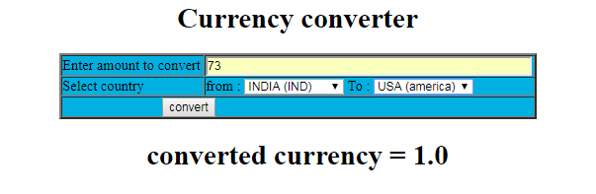

**Practical No. 9.5:- Write a program for servlet for Quize Assignment.**

**Source Code:**

**Index.html:-**

<!DOCTYPE html>

<!--

To change this license header, choose License Headers in Project Properties.

To change this template file, choose Tools | Templates

and open the template in the editor.

-->

<html>

<head>

<title>TODO supply a title</title>

<meta charset="UTF-8">

<meta name="viewport" content="width=device-width">

</head>

<body>

<form action="quize" method="post">

Enter Your Name: <input type="text" name="t1"><br/><br/>

<p>1.Which is a reserved word in the Java.lang?<br/>

<input type="radio" name="1" value="A">A.method<br/>

<input type="radio" name="1" value="B">B.native<br/>

<input type="radio" name="1" value="C">C.Refernce<br/>

<input type="radio" name="1" value="D">D.array<br/>

</p><br/><br/>

<p>2.Which method used to start thread Execution?<br/>

<input type="radio" name="2" value="A">A.init()<br/>

<input type="radio" name="2" value="B">B.Start()<br/>

<input type="radio" name="2" value="C">C.Run()<br/>

<input type="radio" name="2" value="D">D.Resume()<br/>

</p><br/><br/>

<p>3.Data Types for the field:number of Eggs<br/>

<input type="radio" name="3" value="A">A.Int<br/>

<input type="radio" name="3" value="B">B.Double<br/>

<input type="radio" name="3" value="C">C.Boolean<br/>

<input type="radio" name="3" value="D">D.Char<br/>

</p><br/><br/>

<p>4.Size of CHAR in Java:<br/>

<input type="radio" name="4" value="A">A.16 Bits<br/>

<input type="radio" name="4" value="B">B.6 bits<br/>

<input type="radio" name="4" value="C">C.4 bits<br/>

<input type="radio" name="4" value="D">D.2 bits<br/>

</p><br/><br/>

<p>5.What is the role of constructor?<br/>

<input type="radio" name="5" value="A">A.names for method<br/>

<input type="radio" name="5" value="B">B.Change state of object<br/>

<input type="radio" name="5" value="C">C.instance of class<br/>

</p><br/><br/>

<input type="submit" value="Submit Form">&nbsp;&nbsp;&nbsp;

<input type="reset" value="Clear Form">

</form>

</body>

</html>

**Quize.java:-**

protected void processRequest(HttpServletRequest request, HttpServletResponse response)

throws ServletException, IOException {

response.setContentType("text/html;charset=UTF-8");

try (PrintWriter out = response.getWriter()) {

String name=request.getParameter("t1");

String a1=request.getParameter("1");

String a2=request.getParameter("2");

String a3=request.getParameter("3");

String a4=request.getParameter("4");

String a5=request.getParameter("5");

int count=0;

if(a1.equals("B"))

{

count++;

}

if(a2.equals("C"))

{

count++;

}

if(a3.equals("A"))

{

count++;

}

if(a4.equals("A"))

{

count++;

}

if(a5.equals("C"))

{

count++;

}

out.println("<!DOCTYPE html>");

out.println("<html>");

out.println("<head>");

out.println("<title>Servlet quize</title>");

out.println("</head>");

out.println("<body>");

out.println("<h1>Name: " +name+ "</h1>");

out.println("<h1>Score: " +count+ "</h1>");

out.println("</body>");

out.println("</html>");

}

}

**Output:**

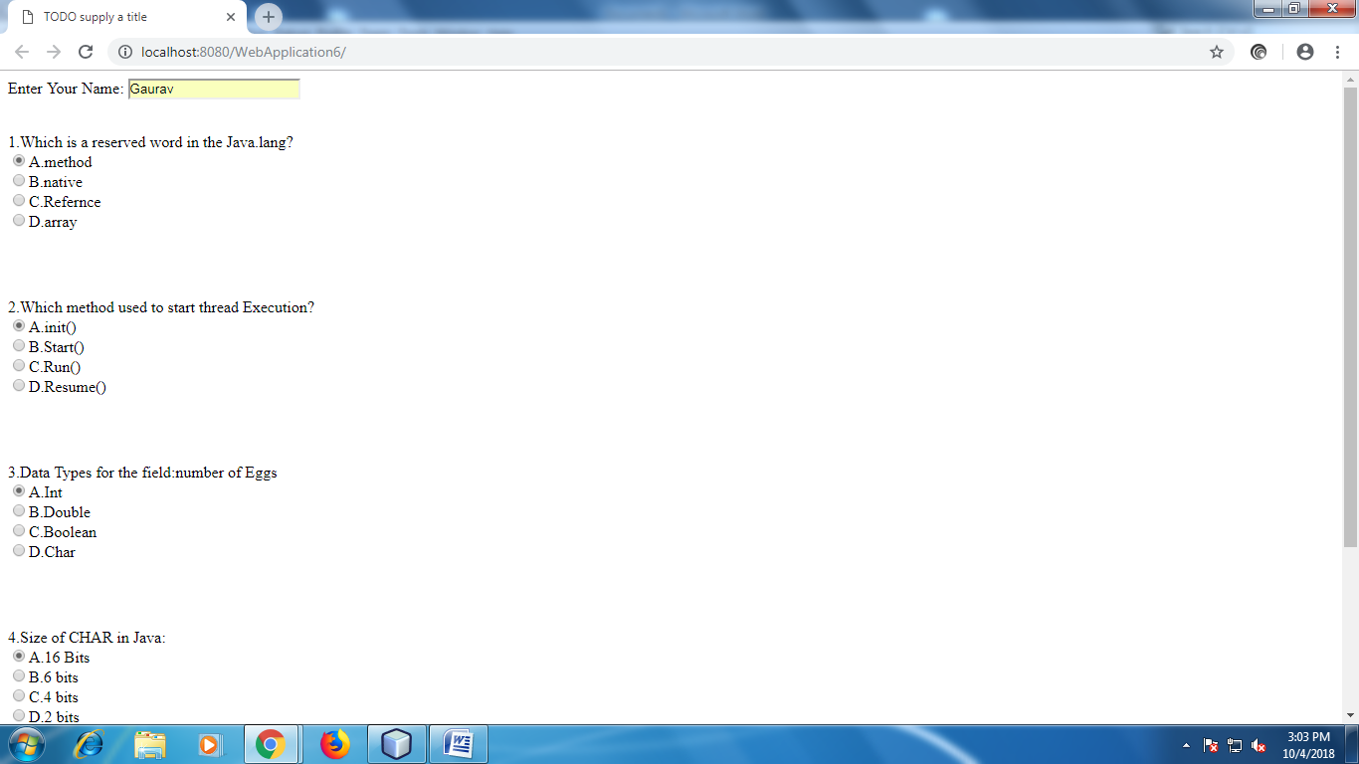

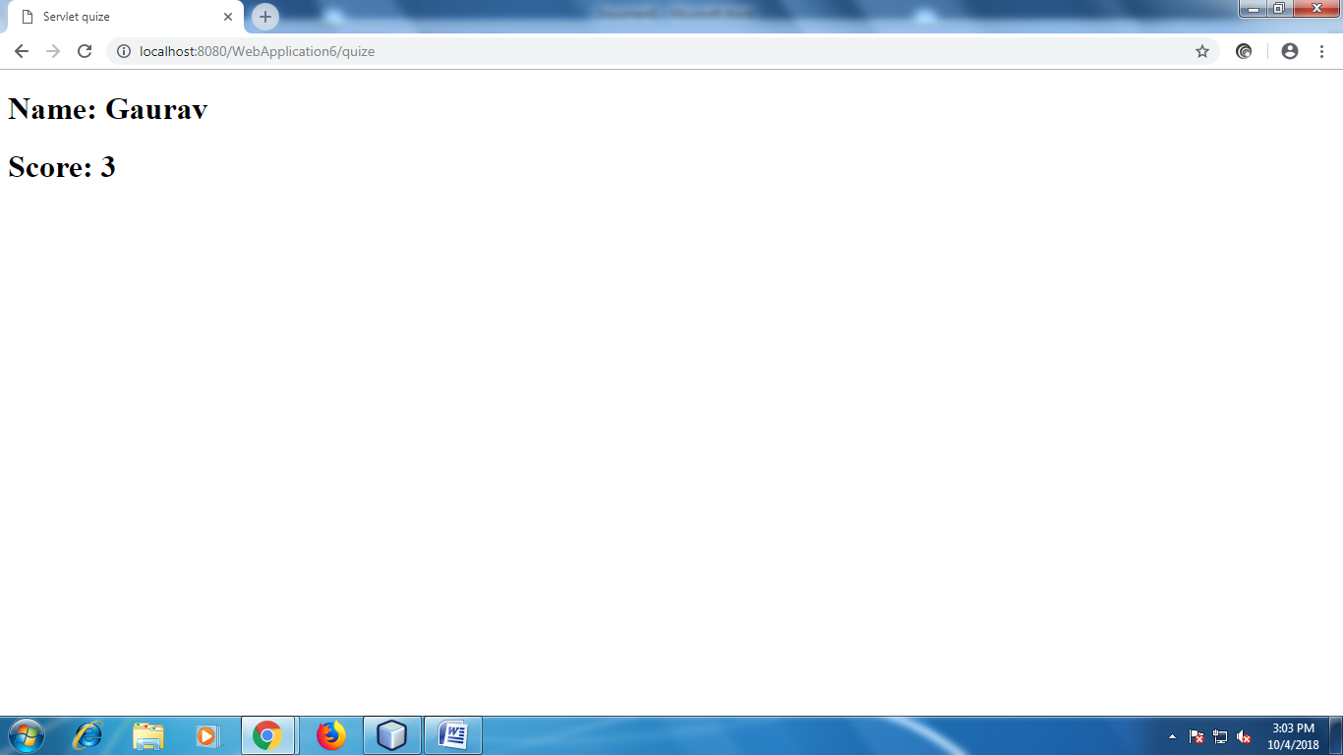

**Practical No. 9.6:- Write a program for login page in JSP.**

**Source Code:**

<%--

Document : login

Created on : Oct 8, 2018, 10:08:09 AM

Author : Student

--%>

<%@page contentType="text/html" pageEncoding="UTF-8"%>

<!DOCTYPE html>

<html>

<head>

<meta http-equiv="Content-Type" content="text/html; charset=UTF-8">

<title>Login Page</title>

</head>

<body>

<table align="center" border="2">

<caption>Login Page</caption>

<form action="Login" method="POST">

<tr><td>Enter Username :</td><td> <input type="text" name="name"></td></tr>

<tr><td>Enter password :</td><td> <input type="password" name="pwd"></td></tr>

<tr><td colspan="2" align="center"><input type="submit" value="login">

<input type="reset" value="reset"></td></tr>

</form>

</table>

</body>

</html>

**Login.java:**

try (PrintWriter out = response.getWriter()) {

/* TODO output your page here. You may use following sample code. */

String name=request.getParameter("name");

String pwd=request.getParameter("pwd");

if(name.equals("vikas") && pwd.equals("anil"))

{

response.sendRedirect("success.jsp");

//out.println("welcome "+name+ " you are logged in");

}

else

{

response.sendRedirect("error.jsp");

out.println("failed");

**Success.jsp:**

<!DOCTYPE html>

<html>

<head>

<meta http-equiv="Content-Type" content="text/html; charset=UTF-8">

<title>JSP Page</title>

</head>

<body>

<h1>welcome </h1>

</body>

</html>

**Error.jsp:**

<html>

<head>

<meta http-equiv="Content-Type" content="text/html; charset=UTF-8">

<title>JSP Page</title>

</head>

<body>

<h1>login failed.....invalid uname or pwd</h1>

<a href="login.jsp">Retry login </a>

</body>

</html>

**Output:**

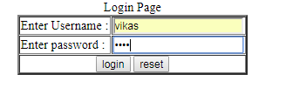

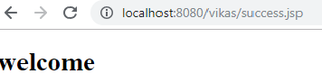

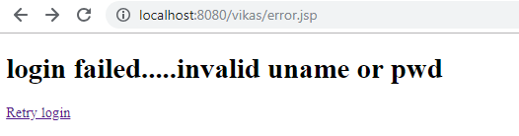

**Practical No. 9.7: Write a program Grade Calculator.**

**Source Code:**

**Grade.jsp**

<html>

<head>

<meta http-equiv="Content-Type" content="text/html; charset=UTF-8">

<title>GRADE CALCULATOR</title>

</head>

<body>

<table align="center" border="2">

<caption><B>GRADE CALCULATOR</caption>

<form action="Grade" method="POST">

<tr><th>Student name :</th><td> <input type="text" name="name"></td></tr>

<tr><th>LAB attendance :</th><td> <input type="text" name="lab"></td></tr>

<tr><th>Total LAB attendance :</th><td> <input type="text" name="lab2"></td></tr>

<tr><th>Theory attendance :</th><td> <input type="text" name="theory"></td></tr>

<tr><th>Total Theory attendance :</th><td> <input type="text" name="theory2"></td></tr>

<tr><th>Mid term marks :</th><td> <input type="text" name="mid"></td></tr>

<tr><th>Total mid term marks :</td><td> <input type="text" name="mid2"></td></tr>

<tr><th>final marks :</th><td> <input type="text" name="final"></td></tr>

<tr><th>Total final marks :</th><td> <input type="text" name="final2"></td></tr>

<tr><td colspan="2" align="center"><input type="submit" value="Calculate grade">

<input type="reset" value="reset"></td></tr>

</form>

</table>

</body>

</html>

**Grade.java**

try (PrintWriter out = response.getWriter()) {

/* TODO output your page here. You may use following sample code. */

String name=request.getParameter("name");

int lab=Integer.parseInt(request.getParameter("lab"));

int lab2=Integer.parseInt(request.getParameter("lab2"));

int theory=Integer.parseInt(request.getParameter("theory"));

int theory2=Integer.parseInt(request.getParameter("theory2"));

int mid=Integer.parseInt(request.getParameter("mid"));

int mid2=Integer.parseInt(request.getParameter("mid2"));

int final1=Integer.parseInt(request.getParameter("final"));

int final2=Integer.parseInt(request.getParameter("final2"));

int sum=mid+final1;

int total=mid2+final2;

float per=sum*100/total;

out.println("<center>" );

out.println("<font color=blue size=7>welcome " + name + " your result </font><br>" );

out.println("<font color=red size=5>Percentage of LAB attendance " +lab*100/lab2 + "<br>");

out.println("<font color=red size=5>Percentage of Theory attendance " +theory*100/theory2 + "<br>");

out.println("<font color=dark blue size=6> Total Percentage " +per + "<br>");

String ch="fail";

if(per>=80)

{

ch="O grade";

}

else if (per<80 && per>=60)

{

ch="A Grade";

}

else if (per<60 && per>=55)

{

ch="B Grade";

}

else if (per<55 && per>=45)

{

ch="C Grade";

}

else if (per<45)

{

ch="failed";

}

out.println("<big>GRADE = " + ch + "<br>");

out.println("</center>" );

}

}

**Output:**

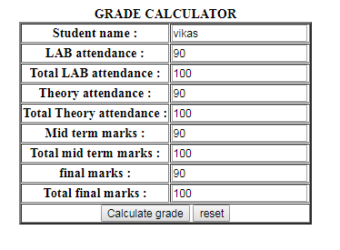

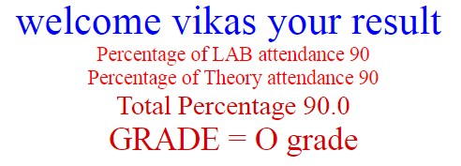

**Practical No. 9.8: Write a program for Display Last Visit Date.**

**Source Code:**

**Calculate.java:**

protected void processRequest(HttpServletRequest request, HttpServletResponse response)

throws ServletException, IOException {

response.setContentType("text/html;charset=UTF-8");

try (PrintWriter out = response.getWriter()) {

/* TODO output your page here. You may use following sample code. */

int cnt=1;

HttpSession hs=request.getSession(true);

Date date=(Date) hs.getAttribute("date");

if(date!=null)

{

out.println("Last Access: "+date);out.println("<br/><br/>");

out.println("Last WebPage Count: "+cnt);out.println("<br/><br/>");

}

date=new Date();

hs.setAttribute("date",date);

cnt=cnt+1;

out.println("Current Date: "+date);out.println("<br/><br/>");

out.println("Current Webpage count: "+cnt);out.println("<br/><br/>");

}

}

**Output:**

